**國 立 成 功 大 學**

**電 機 工 程 學 系**

**碩 士 論 文**

**多感知偵測演算法於自駕車之系統建置**

**Development of Multiple Sensor**

**Detection Algorithms for**

**Autonomous Driving Vehicle**

|  |  |
| --- | --- |
| **研 究 生：陳威廷** | Student: Wei-Ting Chen |
| **指導教授：莊智清** | Advisor: Jyh-Ching Juang |

Department of Electrical Engineering

National Cheng Kung University

Tainan, Taiwan, R.O.C.

Thesis for Master of Science

July, 2019

**中華民國一百零八年七月**

**多感知偵測演算法於自駕車之系統建置**

陳威廷† 莊智清‡

國立成功大學電機工程學系

# 摘要

**關鍵字**:

† **研究生**

‡  **指導教授**

**Development of Multiple Sensor**

**Detection Algorithms for**

**Autonomous Driving Vehicle**

Wei-Ting Chen † Jyh-Ching Juang‡

*Department of Electrical Engineering*

*National Cheng Kung University, Tainan, Taiwan*

# Abstract

Autonomous driving vehicle is the technology that will appear in daily life very soon. By 2025, the world will see millions of autonomous vehicles on the roads, and safety is undoubtedly the most important topic in this field. In this thesis, a multi-sensor data fusion system for multiple computers autonomous vehicle is developed. Environment perception is the foundation for ensuring safety, so accurate obstacles detection and tracking are critical aspects of autonomous driving.

Autonomous driving system contains vehicle, sensors, communication equipment and on-board computers. To improve system performance, this thesis proposed a parallel computing mechanism on two computers and complete architecture for sensor data processing and decision-making.

Multiple sensors including camera, lidar, and radar provide feasibility and complementarity for this goal. Raw data preprocessing, data format definition, and fusion algorithm development are integrated in the NCKU autonomous vehicle system based on Robot Operating System (ROS), which provides good modular development environment.

Camera has good classification ability; Lidar performs well in bad lighting environment; Radar provides long-range coverage and good velocity information. Deep Learning and Kalman Filter are used to implement detection-level and tracking-level fusion algorithm. Sensor fusion mechanism of autonomous vehicle is experimented on the campus road with vehicles and pedestrians. In the thesis, pedestrians tracking performance is focused on.

In order to increase safety and decrease road accidents of autonomous vehicles, tests in a controlled environment and/or open fields are essential. In the future, we will make efforts on adapting the system from the campus road to the urban road.

**Keywords**: Autonomous Vehicle, Sensor Fusion, Object Perception

† **The Student**

‡ **The Advisor**

# Acknowledgements

感謝

# Contents

摘要 I

Abstract II

Acknowledgements IV

Contents V

List of Tables VIII

List of Figures IX

Chapter 1 Introduction 1

1.1 Motivation and Objectives 1

1.2 Literature Review 1

1.2.1 Autonomous Driving Vehicle 1

1.2.2 Perception Module 4

1.3 Thesis Overview 7

Chapter 2 PHOENIX ADCS 8

2.1 Attitude Determination and Control Subsystem 8

2.1.1 Coordination Definition 8

2.1.2 ADCS Module Specification 9

2.1.3 Control and Estimation Modes 11

2.2 In-Flight ADCS Experience 13

2.2.1 High Rate Detumbling 13

2.2.2 Y-Spin Control 15

2.2.3 Y-momentum Control 17

Chapter 3 In-Flight TAM Calibration Methods 20

3.1 Mathematical Model of Magnetometer 20

3.1.1 External Errors 20

3.1.2 Internal Errors 21

3.1.3 Measurement Model of 3-Axis Magnetometer 24

3.2 Review of Existing Calibration Methods 27

3.2.1 Least Square Method 27

3.2.2 TWOSTEP Algorithm 28

3.2.3 Nonlinear-Kalman-Filter Based Algorithm 30

3.2.4 Particle Swarm Optimization 31

3.3 PSO-Based Magnetometer Calibration 31

3.3.1 Particles Initialization 32

3.3.2 Particles Evaluation 33

3.3.3 Particles Update 33

Chapter 4 In-Flight TAM Calibration and Verification 36

4.1 Background 36

4.1.1 3-Axis Magnetometer of PHOENIX 36

4.1.2 Thermometers of PHOENIX 38

4.1.3 IGRF Model 40

4.1.4 In-Flight Data Collection 42

4.2 Ground-Calibration with In-Flight Data 44

4.2.1 CubeSupport Calibration 44

4.2.2 PSO-Based Calibration 45

4.2.2.1 Initial Parameters Setting 46

4.2.2.2 Comparison Test 48

4.2.2.3 Results of PSO-Based Calibration 48

4.3 In-Flight Test of Calibrated Parameters 58

4.4 Further Study of Magnetometer Calibration 62

4.4.1 The Setting of Temperature Reference *T*0 62

4.4.1.1 Comparison with Results from CubeSupport 64

4.4.2 Analysis of PSO-Based Calibration 67

4.4.2.1 Different Setting of Initial Boundary 67

4.4.2.2 Dynamic Weighting Parameters 70

Chapter 5 Conclusions and Future Works 73

5.1 Discussions 73

5.2 Future Works 75

References 78

# List of Tables

Table 1‑1 Structure Configuration of PHOENIX 8

Table 2‑1 Specification of ADCS Sensors [9] 12

Table 2‑2 Specification of ADCS Actuators [9] 13

Table 2‑3 ADCS Control Modes [10] 14

Table 2‑4 ADCS Estimation Modes [10] 15

Table 2‑5 Calibrated Parameters Applied for Y-spin Control 19

Table 4‑1 Parameters for PSO-Based Calibration 50

Table 4‑2 Analysis of Errors in Figure 4‑14 52

Table 4‑3 Calibrated Parameters Computed by PSO-Based Calibration 56

Table 4‑4 Estimation of Calibrated Parameters with Different Sizes of Particle Swarm 59

Table 4‑5 Analysis of Errors in Figure 4‑26 63

Table 4‑6 Analysis of the Errors in Figure 4‑29 66

Table 4‑7 Calibrated Parameters from CubeSupport and PSO 68

Table 4‑8 Initial Boundary Settings [min, max] 70

Table 4‑9 Analysis Results after 50 Runs for Three Cases 72

Table 4‑10 Calibrated Parameters of Two Runs with Acceptable Fitness 72

Table 4‑11 Analysis Results after 50 Runs of Three Cases with Dynamic Weightings 75

# List of Figures

Figure 1‑1 Mission Objectives of QB50 Project [1] 5

Figure 1‑2 Two Launch Campaigns in QB50 Mission [1] 6

Figure 1‑3 Distribution of QB50 CubeSats Constellation [1] 6

Figure 1‑4 Configuration of PHOENIX CubeSat 7

Figure 1‑5 Flight Configuration of INMS Science Payload 8

Figure 1‑6 CATIA Model (left) and Fight Model (right) 8

Figure 1‑7 Deployment Scenario of PHOENIX (Flight Over Southeast Asia) 9

Figure 2‑1 PHOENIX 3-Axis Coordination Definition (left), ADCS Module (right) 11

Figure 2‑2 Flight Scenario with Desired Attitude 12

Figure 2‑3 Operation Loop of Magnetic Sensor and Actuator [10] 13

Figure 2‑4 Overall Control Scenario 16

Figure 2‑5 3-Axis Magnetometer Measurements under High Tumbling Rate [13] 17

Figure 2‑6 Detumbling Control Timeline [13] 18

Figure 2‑7 Y-Spin Control with Wrong Setting of Calibrated Parameters 19

Figure 2‑8 3-axis Magnetometer Measurements under Y-spin Control 20

Figure 2‑9 3-axis Angular Rate under Y-spin Control 20

Figure 2‑10 ADCS Data under Y-Momentum Control 21

Figure 2‑11 3-axis Magnetometer Measurements under Y-Spin (left), and 22

Figure 3‑1 Wheatstone Bridge with Anisotropic Magnetoresistive Elements [16] 25

Figure 3‑2 Flowchart of PSO Algorithm 38

Figure 4‑1 3-axis Magnetometer (left) and Coordination Definition (right) 39

Figure 4‑2 Locations of Accessible Thermometers 41

Figure 4‑3 In-Flight Temperature Measurements 41

Figure 4‑4 Sunlit/Eclipse Part of the Orbit 42

Figure 4‑5 Observation of Delayed OBC Time 44

Figure 4‑6 Time Information in SCS Communication Software 44

Figure 4‑7 Change of Magnitude of Magnetic Field every 1 sec. 44

Figure 4‑8 Schematic Scenario of In-Flight Data Collection 45

Figure 4‑9 Magnitudes of Raw Magnetometer Measurements and IGRF Model 46

Figure 4‑10 Graphic Interface of Magnetometer Calibration in CubeSupport 47

Figure 4‑11 Final Calibration Results from CubeSupport 48

Figure 4‑12 Uniformly Distributed Positions of the Particle Swarm 50

Figure 4‑13 Magnitudes of Calibrated Measurements 51

Figure 4‑14 Magnitude Errors of PSO-Based Calibration 52

# Introduction

## Motivation and Objectives

Autonomous driving vehicle is the one of the most important technology in this century, which can not only increase transportation efficiency but also decrease accidents caused by human errors. In order to create new generation transport system, autonomous vehicle is the key, and consequently lots of companies and academic institutions are applying themselves to developing complete mechanism.

Autonomous vehicle system is quite huge which contains vehicle, sensors, computers, and communication equipment. Diversity of sensor provides expansibility for environment sensing as well as integrity for algorithm research. NCKU has one of the best autonomous vehicle R&D teams in Taiwan and a vehicle with complete hardware installed, and the team is making efforts to build a system with characteristic.

To improve automation level, perception system is such as eyes of the vehicle and therefore the performance will influence safety of autonomous vehicle directly. Advanced Driver-Assistance Systems (ADAS) and fully self-driving car rely on perception system, which means research on perception is valuable.

In the thesis, a complete software architecture is proposed and built on NCKU autonomous vehicle. Frontal object perception system is the focus which solved by processing data from lidar, radar, and camera. Using deep leaning and Kalman filter to detect and track potential obstacles. The architecture enables NCKU vehicle to drive more safely; moreover, it lay the foundation related research such as Autonomous Emergency Braking (AEB) System and Level 4 autonomous driving.

## Literature Review

PHOENIX is one of CubeSats in QB50 mission, which is an international project coordinated by von Karman Institute (VKI). The objectives of QB50 project, mission scenario and the design of PHOENIX are briefly described as below [1].

### Autonomous Driving Vehicle

As one of European Union (EU) project, the main objective of QB50 is to realize the multi-point, in-situ scientific measurement with the network of fifty CubeSats in the lower thermosphere. In addition, the demonstration of re-entry technologies is another goal for some CubeSats in this EU project. Four primary objectives are concluded as below [1].

* **Facilitating Access to Space :**

Thanks to the development of new deployment system and qualified launcher interface, QB50 aims to achieve the global scientific researches with the network of CubeSats as a relative low-cost and realistic option. It also promotes the awareness of the CubeSat concept with the great feasibility for space-accessing in a sustainable and affordable way.

* **Scientific Research :**

In QB50 project, there are three groups of CubeSats with different types of science payload, including Ion-Neutral Mass Spectrometer (INMS), Flux-Φ-Probe Experiment (FIPEX) and multi-Needle Langmuir Probe (m-NLP), each will be operated for few month and provide important data for the research of lower thermosphere, which is the least explored layer of the atmosphere.

* **In-Orbit Demonstration :**

In addition to the scientific researches, another objective of QB50 is to serve as the platform for technology demonstration and qualification in space. For example, Inflate Sail CubeSat had successfully demonstrated the de-orbit technology by using an inflatable mast and drag-sail [2]. Other technologies such as propulsion system with Pulsed Plasma Thruster (PPT), Pegasus CubeSat, and deployable side panels, Atlantis and Columbia CubeSats, have been also demonstrated and qualified in space.

* **Education :**

Numerous universities participate in QB50 project. Most of QB50 CubeSats have been designed, developed and built by students and young engineers under supervision of experienced staff at their universities. QB50 project will also provide guidance and support for CubeSat teams. Those students and engineers can learn the knowledge of space engineering, and even pursue related work with their hands-on experience.



**Figure 1‑1 Mission Objectives of QB50 Project [1]**

In May and June 2017, total 28 CubeSats were deployed from International Space Station (ISS) in LEO about 400 km. altitude and 51.6 deg. inclination. 8 CubeSats were deployed from a PSLV rocket into the sun-synchronous orbit with 500 km. altitude 97.1 deg. inclination. Later, a sequence of communication, ADCS and science payload commissioning have been implemented. Figure 1‑3 presents the distribution of QB50 CubeSats constellation.

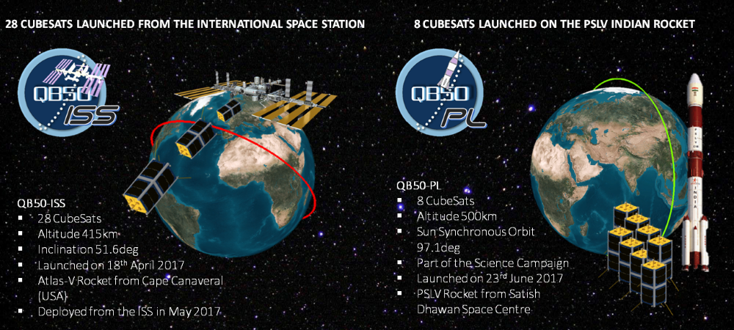

Figure 1‑2 Two Launch Campaigns in QB50 Mission [1]

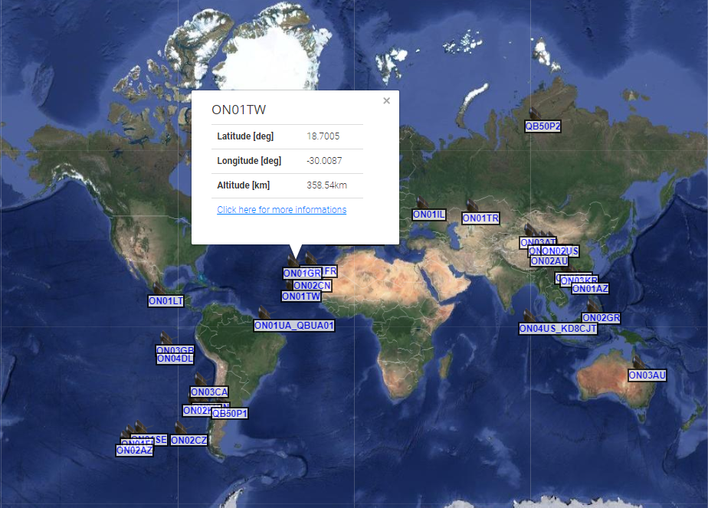

Figure 1‑3 Distribution of QB50 CubeSats Constellation [1]

### Perception Module

PHOENIX is a 2U CubeSat developed by SPACE Lab in NCKU. The overall structure, subsystems and components are shown in Figure 1‑4.

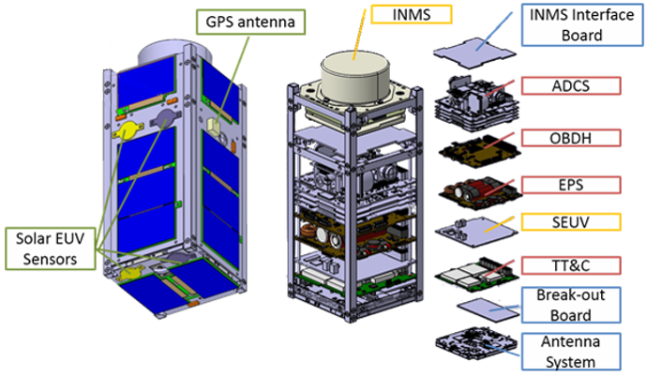

Figure 1‑4 Configuration of PHOENIX CubeSat

There are two kinds of science payloads adopted for PHOENIX CubeSat. Firstly, INMS payload, provided by Mullard Space Science Laboratory (MSSL) at UCL in UK, is the major science payload with the objective to measure the neutral and single ionized states of O, O2, N, N2 and NO in the lower thermosphere. Figure 1‑5 shows the flight configuration of INMS module on the top of PHOENIX, which the tiny pinholes on the top of cylindrical shield allow inner sensors to measure the incoming neutral and ionized particles along the fight direction. On the other hands, Solar Extreme Ultraviolet (SEUV) sensors, developed by Lab Atmospheric Electricity (LAE) at NCKU, are viewed as a secondary science payload to measure and study the solar extreme ultraviolet in space.

In addition to the science payloads, PHOENIX basically consists of four subsystems, SMS, OBDH, EPS, TT&C and ADCS. Other modules such as GPS receiver, GPS antenna, interface board, break-out board and antenna board are also the important components of PHOENIX. Further discussions about the design of flight software (FSW) for PHOENIX can be found in [3], and detailed EPS- and TT&C-related studies can be found in [4] and [5] respectively. On the other hand, about ADCS, design and simulation of the software-in-the-loop (SIL) verification have been developed and implemented based on MATLAB/Simulink environment, which can be found in [6], [7] and [8].

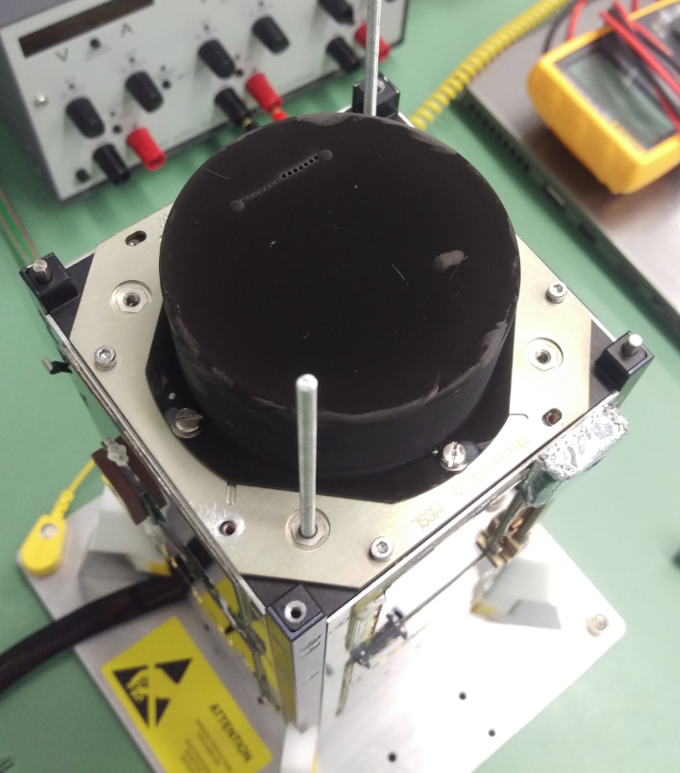

Figure 1‑5 Flight Configuration of INMS Science Payload

Moreover, based on the CATIA model and actual flight model, which are shown in Figure 1‑6, Table 1‑1 shows the basic structure configuration of PHOENIX.

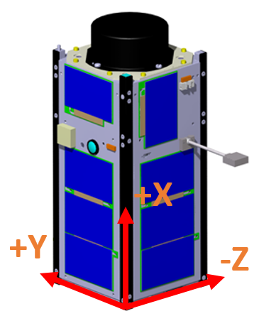 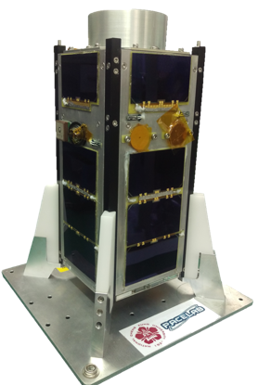

Figure 1‑6 CATIA Model (left) and Fight Model (right)

Table 1‑1 Structure Configuration of PHOENIX

|  |  |
| --- | --- |
| **Item** | **Description** |
| Satellite Number | 42706 |
| Type | 2U CubeSat |
| Dimension | 10cm × 10cm × 25.81cm |
| Mass | 1.943 kg. < 2 kg. |
| Moment of Inertia |  |

In May 17, 2017, PHOENIX was deployed by NanoRacks CubeSat Deployer (NRCSD) from ISS on 01:40 (UTC time), shown in Figure 1‑7. Since then, several tasks have been carried out, such as basic functional check and commissioning of communication, ADCS and science payloads. Also, some anomalies and challenges have been addressed and cautiously overcame. Currently, PHOENIX continuously collects and transmits both INMS and SEUV science data to the ground station in a stable manner. This thesis depicts the in-orbit experience of attitude control, then puts the emphasis on the in-flight magnetometer calibration as one of important operation tasks.

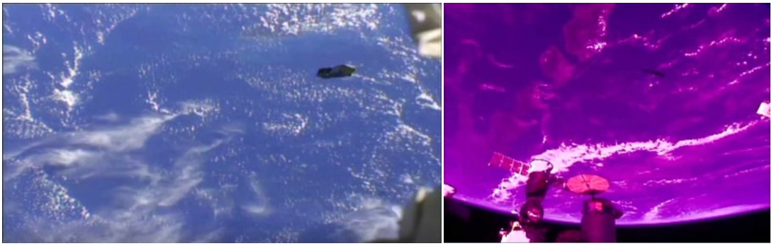

Figure 1‑7 Deployment Scenario of PHOENIX (Flight Over Southeast Asia)

## Thesis Overview

This thesis is organized into chapters as follows.

* **Chapter 2** **– PHOENIX ADCS** **:**

The ADCS of PHOENIX will be introduced in Chapter 2. Especially, it will focus on the design of ADCS, and magnetometer-related applications for PHOENIX. Later, to clearly understand the actual implementation with magnetometer measurements, in-fight experience of ADCS will be presented, and magnetometer-related issue will be pointed out.

* **Chapter 3** **– In-Flight TAM Calibration Methods :**

Firstly, the sources of measurement errors will be explained and mathematically modeled. Temperature-dependent property of magnetometers will be highlighted. Later, several existing calibration methods will be briefly described, and the algorithm of PSO-based calibration will be introduced in detail and applied in this thesis. Furthermore, the inherent advantages of PSO-based algorithm will be explained.

* **Chapter 4 – In-Flight TAM Calibration and Verification :**

Actual data from PHOENIX will be analyzed to verify the proposed temperature-dependent model and PSO-based calibration. The performance of PSO-based calibration will be also discussed. Finally, further studies, which can significantly improve the calibration performance, will be introduced and explained.

* **Chapter 5 – Conclusions and Future Works :**

All the observations and performances of the proposed approach will be comprehensively discussed. Future works and potential application will also be concluded in this chapter.

# PHOENIX ADCS

## Attitude Determination and Control Subsystem

### Coordination Definition

Firstly, the definition of 3-axis coordination for PHOENIX is shown in Figure 2‑1 (left), and the ADCS module, provided by Surrey Space Centre at University of Surrey in UK, is shown in Figure 2‑1 (right).

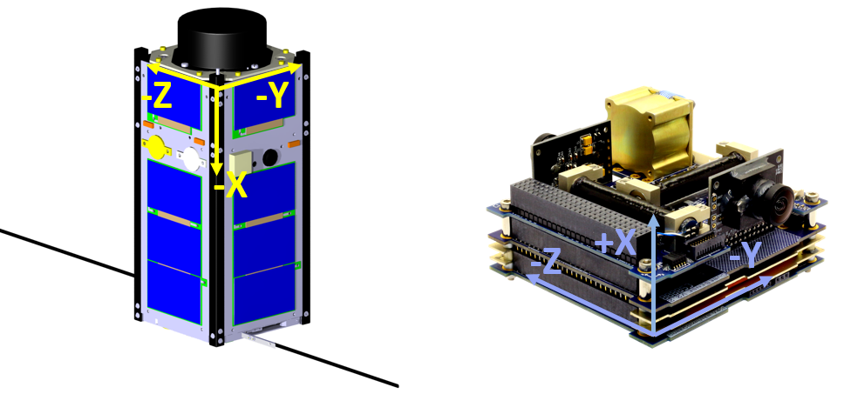

Figure 2‑1 PHOENIX 3-Axis Coordination Definition (left), ADCS Module (right)

The desired attitude of PHOENIX is in the 3-axis alignment with the orbit-reference frame, namely, X-axis aligns with the flight direction, Z-axis points to the nadir direction and Y-axis points to the direction of negative orbit normal. Figure 2‑2 shows the fight scenario with the nominal attitude. With attitude requirement of INMS science payload, ADCS module is responsible for attitude control with a pointing accuracy of ± 10 degrees and attitude pointing knowledge of ± 2 degrees.

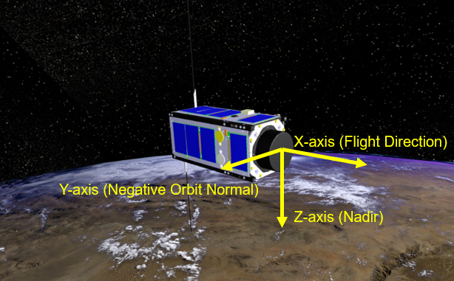

Figure 2‑2 Flight Scenario with Desired Attitude

### ADCS Module Specification

ADCS module of the PHOENIX was provided by QB50. The specifications of sensors and actuators adopted for the ADCS module are listed in Table 2‑1 and Table 2‑2 below. The actual sensors and actuators test before flight can be found in [7] and [8].

Table 2‑1 Specification of ADCS Sensors [9]

|  |  |  |  |
| --- | --- | --- | --- |
| **Sensors** | **Description** | **Specification** | **Value** |
| Magnetometer | 3-axis AMR,  Deployable boom | Measurement accuracy | < 50 nT |
| Measurement resolution | 10 nT |
| Y-Gyroscope | Y-axis only,  MEMS | Measurement range | ± 85°/sec. |
| Measurement accuracy | < 0.015°/sec. (1σ) |
| Angular Random Walk | 0.28° / |
| Bias instability | 24°/ hr |
| Sun/Nadir Sensors | 2 CMOS cameras | Sun sensor accuracy | < 0.5° (< 40° from boresight) |
| < 2° (full FOV) |
| Nadir sensor accuracy | < 0.2° (full earth in FOV) |
| FOV (both cameras) | ~180 deg. |
| Coarse Sun Sensors | 6 photodiodes | Measurement accuracy | < 10° (1σ) |

Table 2‑2 Specification of ADCS Actuators [9]

|  |  |  |  |
| --- | --- | --- | --- |
| **Actuators** | **Description** | **Specification** | **Value** |
| Magnetorquers | 3-axis,  Rods (Y & Z ),  Coil (X),  PWM control | Max. magnetic moment | ± 0.24 Am2 (Rod)  ± 0.12 Am2 (Coil) |
| On-time resolution | 10 ms |
| Residual moment | < 0.48 milli-Am2 |
| Momentum Wheel | Y-axis only,  BLDC | Rotational speed range | ± 8000 RPM |
| Max. torque output | 0.23 mNm |
| Wheel inertia | 2.0 kg·mm2 |
| Speed control accuracy | < 5 RPM |

The control loop rate of ADCS module is 1 Hz, which means the measurements and control commands will be updated every 1 second. Moreover, the operation loop of magnetic sensor and actuator is presented in Figure 2‑3.

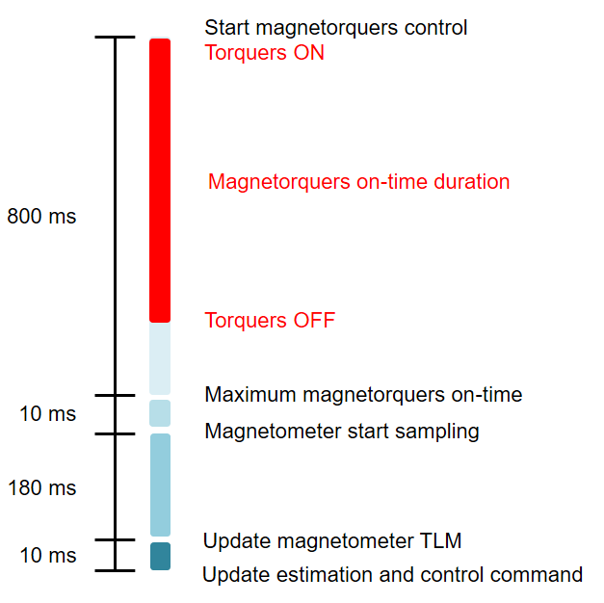

Figure 2‑3 Operation Loop of Magnetic Sensor and Actuator [10]

With the application of PWM control, a maximum of 800ms is allowed for the magnetorquers to be on every 1 second time interval, and the on-time commands are calculated by the function below [10]:

 (2.1)

where *M*demand is the 3-axis magnetic moment calculated by control laws and *M*max is the maximum magnetic moment related to the specification of magnetorquers presented above. In the remaining 200ms, a short duration is required for the magnetic field of the magnetorquers to decay, then magnetometer measurement will be sampled, and updated estimations and control commands will be applied for next control iteration.

### Control and Estimation Modes

To achieve the objective of 3-axis pointing, several control laws and estimation algorithms need to be applied step by step according to the current attitude status of satellite. The overall control laws, estimation modes and related actuators and sensors on-board are listed in Table 2‑3 and Table 2‑4. Detailed descriptions and verification of the algorithms of control modes and estimation modes can be found in [7] and [8].

Table 2‑3 ADCS Control Modes [10]

|  |  |  |
| --- | --- | --- |
| Mode | Required Input | Actuators Used |
| High Initial Rate Detumbling | None | 3-axis Magnetorquers |
| Y-spin Control | Y-axis Angular Rate | 3-axis Magnetorquers |
| Y-momentum Control  - Initial State - | Pitch Angle | Y-momentum Wheel |
| Y-momentum Control  - Steady State - | 3-axis Angular Rates  3-axis Attitude Angles | 3-axis Magnetorquers  Y-momentum Wheel |

Table 2‑4 ADCS Estimation Modes [10]

|  |  |  |
| --- | --- | --- |
| Mode | Estimated Output | Sensors Used |
| Y-MEMS Rate Sensing | Y-axis Angular Rate | Y-MEMS Gyroscope |
| Magnetometer Rate Filter | 3-axis Angular Rates | 3-axis Magnetometer |
| Magnetometer Rate Filter  with Pitch Angle Estimation | 3-axis Angular Rates  Pitch Angle | 3-axis Magnetometer |
| Full-State EKF | 3-axis Angular Rates  3-axis Attitude Angles | 3-axis Magnetometer  Sun/Nadir Sensors  Coarse Sun Sensors |
| TRIAD Algorithm | 3-axis Angular Rates  3-axis Attitude Angles | 3-axis Magnetometer  Sun/Nadir Sensors |

From Table 2‑3 and Table 2‑4 above, it can be observed that the measurements of the 3-axis magnetometer on-board will be mainly applied to estimate 3-axis angular rates and roll, pitch, yaw attitude angles. Moreover, during the eclipse parts of orbits, optical sensors such as Sun/Nadir sensors and coarse sun sensors cannot support the estimation for “Full-State EKF” and “TRIAD Algorithm”, instead, 3-axis pointing control will solely rely on the estimation from the specific estimator, “Magnetometer-Only EKF”. On the other hand, for all control laws of ADCS, not only errors between estimated states and reference values, but also additional inputs such as the sign and vector of the instantaneous 3-axis magnetometer measurement are required to calculate the command outputs for the 3-axis magnetorquers. Therefore, it can be foreseen that the accuracy of magnetometer measurements will significantly affect the performance of attitude estimation and even attitude control for PHOENIX.

Figure 2‑4 shows the schematic diagram of the overall control scenario [11]. The control mode, “High Initial Rate Detumbling”, will be only conducted when satellite is under high rate tumbling, then detumbling can be accomplished based on the typical 3-axis B-dot control with the rate of change of magnetometer readings input. Moreover, it should be noted that the control mode, “Y-momentum control”, has two stages. In the initial state, only Y-momentum wheel will be activated and controlled to a “constant” rotational speed, then satellite will spin around Y-axis at the lower rate. Later, full-state attitude control will be implemented when pitch angle of satellite is within ± 10 degrees of the reference pitch angle (along with flight direction). Detailed descriptions about the control process and related simulations can be found in [7], [8], [11] and [12].

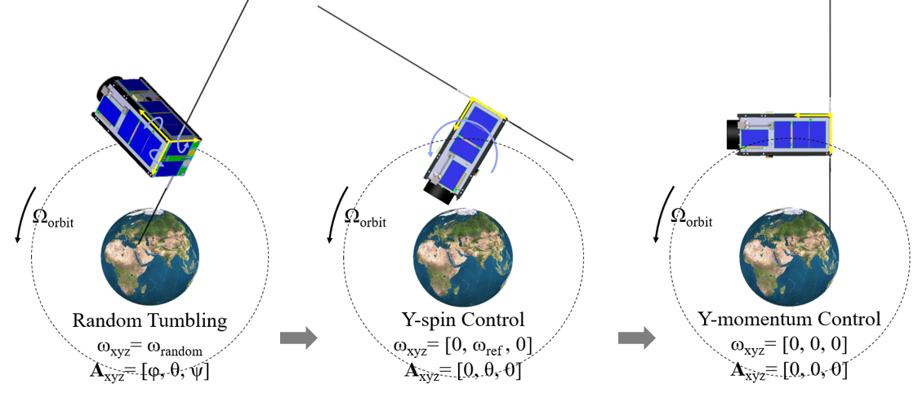

Figure 2‑4 Overall Control Scenario

## In-Flight ADCS Experience

This section will present the actual experience of in-flight ADCS commissioning for PHOENIX CubeSat. It’s majorly categorized into three different control scenarios, high rate detumbling, Y-spin control and Y-momentum control. In the meantime, magnetometer-related application will also be emphasized.

### High Rate Detumbling

Due to the design issue of the auto-attitude-control software, PHOENIX was subject to a high tumbling behavior (more than 100 deg./sec.) during the initial commissioning phase, and even the readings of the Y-MEMS gyroscope was saturated.

To account for this phenomenon, magnetometer measurements and B-dot control became to be the only way to recover the satellite from high rate tumbling [13], [14]. Figure 2‑5 shows the intermittent 3-axis magnetometer measurements data collected under high rate tumbling during a short duration.

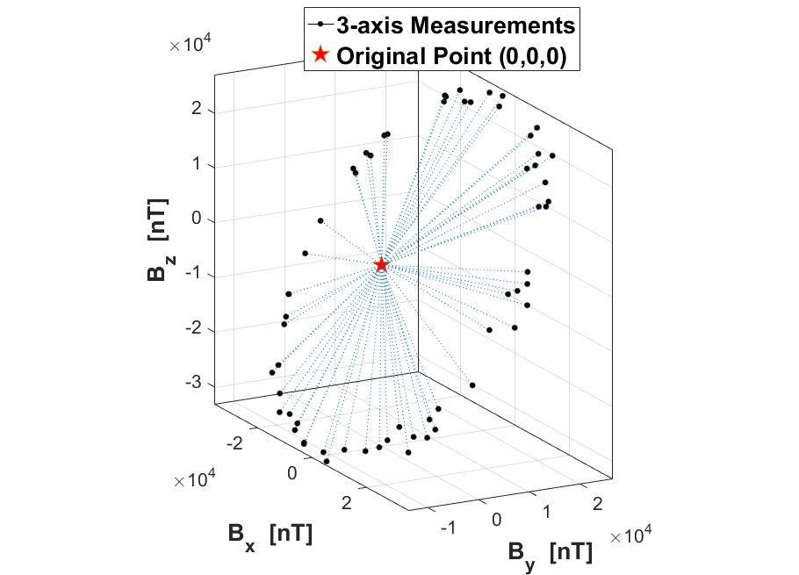

Figure 2‑5 3-Axis Magnetometer Measurements under High Tumbling Rate [13]

With the measurements of 3-axis magnetic vectors, the direction and the magnitude of rotation can be observed and determined approximately. In Figure 2‑5, the rotation axis roughly lies on the unit vector as [–0.09, 0.83, –0.54] in the body frame, then the magnitude of rotation can be determined by analyzing the change in the phase angle of the projection of the magnetic vectors on the plane perpendicular to the rotation axis, and 155 deg./sec. tumbling rate was estimated. Then, “High Initial Rate Detumbling” control mode had been cautiously applied with different settings of polarity of magnetic dipole moment according to the tumbling rate estimation, and the final result of detumbling control is shown in Figure 2‑6.

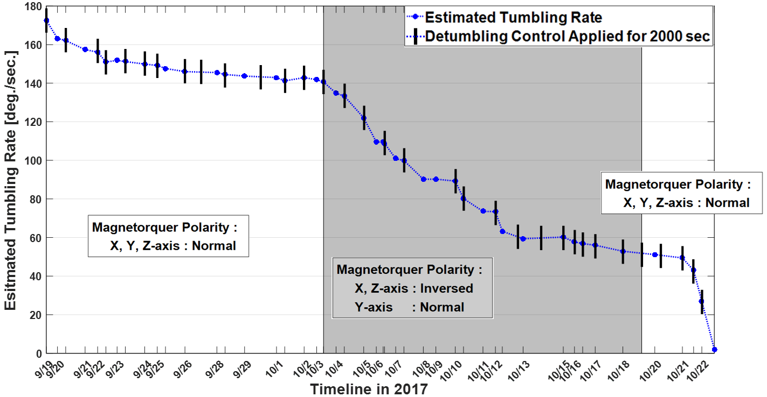

Figure 2‑6 Detumbling Control Timeline [13]

It should be noted that the estimator, “Magnetometer Rate Filter”, cannot determine the 3-axis angular rate correctly due to the fast changing orientation of measurement vectors [11]. The detumbling control, based on the typical B-dot algorithm, will also be influenced by the latency between the time the magnetic field is sampled and when the torque is applied, and the polarity of the magnetorquers output should be adjusted correspondingly. Further researches about the transition conditions for the change of polarity setting can be studied in the future, and here shows one of the important applications of the 3-axis magnetometer.

### Y-Spin Control

The objective of Y-spin control is to make satellite spin along Y-body axis at the desired rate (the spin axis will eventually align with the axes of orbital normal), and also to damp the X/Z-body rates in the meantime. However, due to the incorrect setting of calibrated parameters of magnetometer, Y-spin control of PHOENIX had been found to be ineffective as shown in Figure 2‑7. The corresponding calibrated parameters are listed in Table 2‑5. Note that some parameters with incorrect signs had been uploaded.



Figure 2‑7 Y-Spin Control with Wrong Setting of Calibrated Parameters

Table 2‑5 Calibrated Parameters Applied for Y-spin Control

|  |  |  |
| --- | --- | --- |
|  | **Wrong Parameters** | **Corrected Parameters** |
| Sensitivity Matrix |  |  |
| Bias |  |  |

Therefore, after uploading the corrected parameters, Figure 2‑8 shows the 3-axis magnetometer measurements (collected during short time duration) under improved Y-spin control, and Figure 2‑9 shows the 3-axis angular rates estimation from the estimator, “Magnetometer Rate Filter”. It can be found that the performance of Y-spin control was improved. PHOENIX rotated around its Y-body axis at the reference rate, ‒2.2 deg./sec., and the magnetometer measurements present less magnitude change in the Y-axis. In addition, this experience eventually shows the importance of correct magnetometer measurements for ADCS of PHOENIX.

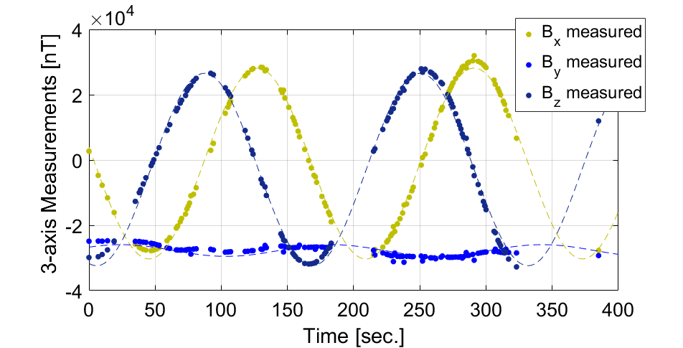

Figure 2‑8 3-axis Magnetometer Measurements under Y-spin Control

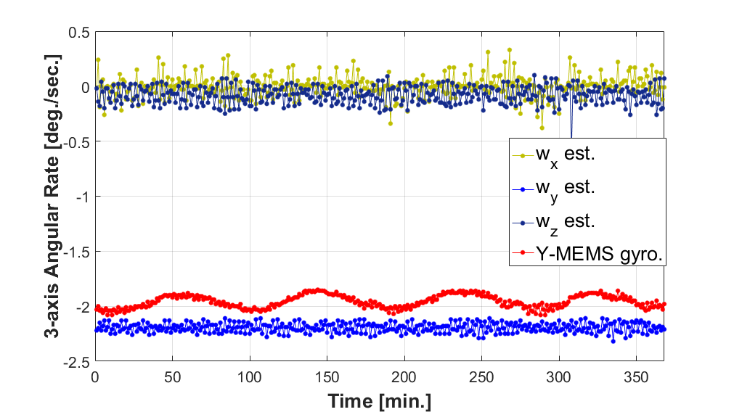

Figure 2‑9 3-axis Angular Rate under Y-spin Control

### Y-momentum Control

After PHOENIX was stabilized in Y-spin status, “Y-wheel ramp-up test” had been successfully implemented to check and verify the functionality and related setting of the Y-momentum wheel [11]. Later, “Y-momentum Control mode” had been carried out with the goal of 3-axis pointing and stabilization. Figure 2‑10 shows the ADCS data under Y-momentum control. (the sampling rate of in-flight data is 60 seconds). Accordingly, the normalized magnetometer measurements are shown in Figure 2‑11 in which the bold lines represent the geomagnetic-reference vector in the orbit-reference frame. The attitude information was calculated from the estimator “Magnetometer-Only EKF” revealing that the angles of pitch, row and yaw were estimated within the range of ±10 degrees.



Figure 2‑10 ADCS Data under Y-Momentum Control



Figure 2‑11 3-axis Magnetometer Measurements under Y-Spin (left), and

Y-Momentum (right) Control

However, the Y-momentum wheel was found to be saturated after Y-momentum control was applied for a short period, then the satellite started to be out of control and entered an unstable state. Clearly, a fine magnetometer calibration and tuning the parameters of attitude estimator are essential. Furthermore, to check the accuracy of in-flight attitude estimation, magnetometer measurements (with 1 minute sample rate) are later analyzed to post-estimate and reconstruct the 3-axis attitude angle and 3-axis angular rate [15].

Consequently, with the poor calibrated magnetometer measurements, it will not only affect performance of attitude control and estimation, but also may influence the reconstruction of attitude and angular rate with the in-flight magnetometer data. The importance of magnetometer calibration in a reliable manner should be emphasized.

# In-Flight TAM Calibration Methods

This chapter presents the mathematical model of the 3-axis magnetometer and discusses existing calibration methods. The magnetometer calibration is conducted under the in-flight scenario without the correct knowledge of attitude of the satellite. It’s important to state that the following mathematical magnetometer model and calibration methods will be mainly derived and applied to solve the “attitude-independent” problem.

## Mathematical Model of Magnetometer

To establish the mathematical measurement model of the 3-axis magnetometer, one should properly analyze and model several sources of measurement errors, which can be generally categorized into the external errors and the internal errors [16].

### External Errors

About the external errors, in the actual situation, the in-situ measurements will be influenced by additional magnetic field, which comes from the surrounding components such as permanent magnets and ferromagnetic compounds that can induce magnetism with the external magnetic field. These external magnetic perturbations are known as soft and hard iron errors as following.

* ***Soft Iron Errors***

The induced magnetism of the ferromagnetic materials will change its magnetic intensity in the interaction with the Earth’s magnetic field. These disturbances of the induced magnetic field cause unwanted measurements to the 3-axis magnetometer then result in so-called soft iron errors, which are denoted as *S*si and represented as below.

 (3.1)

* ***Hard Iron Errors***

Permanent magnetic field, generated from permanent magnets and magnetic hysteresis in the vicinity of 3-axis magnetometer, makes constant bias in 3-axis measurements and has negligible relationship with the Earth’s magnetic field, which results in hard iron errors. Here, hard iron errors are denoted as *bhi* and written as below.

 (3.2)

Besides, it should be noted that soft and hard iron errors make unwanted bias, scale factors and nonorthogonality errors to the raw measurements, which cannot be simply distinguished from other terms of errors.

* ***Time-Varying Errors***

In addition to soft and hard iron errors, some studies have considered about the effect of time-varying electromagnetic field generated by sources such as currents of solar panels in the sunlit parts of the orbits and the magnetic-coupling effect of the magnetorquers. Thus, additional coefficients and the coupling matrix need to be specified to map the magnitude of the specific current measurements and the dipole moment vectors into the time-varying bias (see [17] and [18] for more detail introduction).

### Internal Errors

Internal errors are the errors produced by the instrument itself, which relate to the fabrication errors, characteristics of magnetic materials and even the principle of measurement. For example, Anisotropic Magnetoresistive (AMR) magnetic sensors measure the strength of the magnetic field, which rely on the voltage difference of the Wheatstone bridge with four AMR components. Figure 3‑1 shows the Wheatstone bridge circuit of the single-axis magnetometer with four AMR elements, in which the electrical resistance of AMR material is dependent on the angle between the direction of the current *I* and the direction of magnetic field vector *B*.

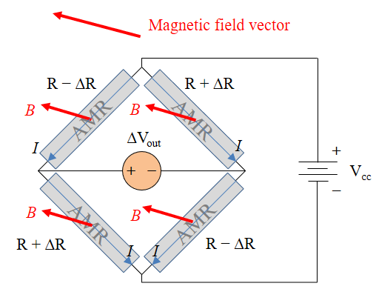

Figure 3‑1 Wheatstone Bridge with Anisotropic Magnetoresistive Elements [16]

From the figure above, the voltage difference ∆Vout can be derived as

 (3.3)

where ∆R represents the change of electrical resistance. Then, the voltage difference can be applied for calculating the strength of sensed magnetic field perpendicular to the Wheatstone bridge circuit. Based on the principle of measurement of AMR magnetic sensors above, internal errors are derived, categorized and explained as following.

* ***Bias***

The slightly difference in the resistance values of four AMR elements causes an offset on the voltage output. The voltage offset results in the measurement bias, which is denoted as ***b*** and mathematically written in three dimensions as:

 (3.4)

* ***Scale Factor***

Due to the nonlinearity of AMR components, the sensitivity the AMR sensors will vary with the different magnitudes of the sensed magnetic field, and results in the scale factor errors, which are denoted as ***S*** and written as below.

 (3.5)

* ***Misalignment Errors***

For the 3-axis magnetometer, three orthogonal Wheatstone bridges are required for measuring the magnetic field in three dimensions. Therefore, the misalignment of 3-axis AMR sensors fabrication causes the nonorthogonality errors, which are denoted as ***M*** and represented by a zero-diagonal symmetric matrix as below [25][26].

 (3.6)

* ***Temperature-Dependent Errors***

Generally, bias, scale factors and misalignment errors are viewed as the most basic calibrated parameters for magnetometer calibration. However, because of the temperature-dependent property of AMR sensors, temperature-dependent errors should not be ignored, especially for the measurements in temperature-varying environment. Moreover, due to the small dimension of the instrument for CubeSats, the magnetic sensing elements are highly susceptible to the temperature effect. As a result, proper values of each calibrated parameter will generally vary with the change of temperature on the platform. In order to compensate the temperature-dependent errors, it needs to define calibrated parameters like bias, scale factors and misalignments as a function of temperature. In this thesis, first order polynomial is experimentally applied to fit the temperature-dependent parameters into linear equations with corresponding temperature coefficients, presented in the following sections [19][20].

### Measurement Model of 3-Axis Magnetometer

With the sources of error mentioned in the previous section, the overall mathematical model of the 3-axis magnetometer then can be derived as below:

 (3.7)

where

***S*** = Scale factors, 3 × 3 diagonal matrix

***M*** = Misalignment terms, 3 × 3 zero-diagonal symmetric matrix

***b*** = Bias, 3 × 1 vector

*I* = 3 × 3 identity matrix

*Ssi* = Soft iron errors, 3 × 3 fully populated matrix

*bhi* = Hard iron errors, 3 × 1 vector

*ε* = Zero-mean Gaussian noise, 3 × 1 vector

*Braw* = Magnetometer raw measurement, 3 × 1 vector

*Btrue* = True and error-free magnetic vector, 3 × 1 vector

All the elements map the error-free magnetic field *Btrue* to the raw magnetic measurement *Braw* with *ε* as zero-mean Gaussian noise in 3-axis. It should be noted that the time-varying errors are not considered in this thesis, because raw measurements will be collected under no control applied, which means no magnetic-coupling effect from the magnetorquers, and the electromagnetic field from the currents of solar panels can mitigated by proper design of placement of current-carrying wires. On the other hand, to minimize the complexities for magnetometer calibration, soft and hard iron errors are modeled as measurement noise. The performance of the simplified model will later be analyzed with the calibration results. Therefore, after expansion and simple manipulation, the equation becomes,

 (3.8)

where

 (3.9)

With the combined measurement noise ***η***, it can be observed that the magnitude of the noise will vary as the change of sensed magnetic field *Btrue* with constant bias *bhi* by the influence of permanent magnetic field on-board.

On the other hand, based on the principle of measurement of AMR sensors and the related studies in [12] and [46], the dependence of each calibrated parameter on temperature is close to linear as a function of temperature. Therefore, to model the temperature-dependent errors, first degree polynomial function is considered for each type of calibrated parameters, and three variables *α*, *β* and *γ* are introduced as the temperature coefficients of scale factors, misalignment terms and bias. Following equation shows the final calibration model of 3-axis magnetometer.

 (3.10)

where

 (3.11)

and

 (3.12)

 (3.13)

where ***S***0, ***M***0 and ***b***0 represent the reference values of scale factors, misalignment terms and bias under constant reference temperature *T*0. Notice that the calibration model requires the information of the in-situ temperature measurements *T*. Here, three temperature coefficients are equal in 3-axis, based on the assumption that temperature-dependent properties of AMR materials are equal in 3-axis AMR magnetic sensors.

Additionally, with no knowledge of attitude matrix of satellite, in-flight calibration can only work with scalar measurements. Therefore, after derivation of the norm of the calibration model and proper manipulation, the adjusted model becomes,

 (3.14)

where

 (3.15)

Here,  represents the rotational matrix that transform *Borbit*, geomagnetic-reference vectors from the orbit frame, to the sensor-body frame. Finally, all 12 calibrated parameters, represented in terms of a vector ***P****est*, are required to be optimized to minimize the difference between the magnitude of *Bcalib* and *Borbit* with the scalar measurement noise *v*.

## Review of Existing Calibration Methods

Based on similar scalar observation models, numerous algorithms for attitude-independent magnetometer calibration have been proposed with various optimization methods and extensions, which are categorized and described as following.

### Least Square Method

With an objective to minimize the sum of squares of norm residuals, two-step least square method has been widely applied for the magnetometer calibration [17][21][22]. The objective function that needs to be minimized is represented as below.

 (3.16)

where the subscript “*i*” represents the index of a batch of data, and there is a total of *m* measurements and geomagnetic reference field vectors.

In the first step, the scalar calibration model needs to be expanded as a combination of terms of defined intermediate variables and the functions of measurements, *f*(*Braw*). With a batch of raw measurements and corresponding magnitudes of geomagnetic reference field, the equation can then be arranged and represented in Eq. (3.17).

 (3.17)

From the equation above, there are *k* intermediate variables, denoted as the vector ***θ****est*. Each intermediate variable is a function of the calibrated parameters ***P****est*. Therefore, based on the implementation of pseudo-inverse, the optimal intermediate variables can be simply estimated, as shown below.

 (3.18)

Later, in the second step, the calibrated parameters, ***P****est*, are computed and extracted from the estimated intermediate variables, ***θ****est*, by solving algebraic equations. However, calibrated parameters are not easily transferable with the full-nonlinear models, and may result in the suboptimal estimation. In addition, it had been indicated that if the geomagnetic reference field is time-varying (the satellite is orbiting around the geomagnetic field), it is required to refine the performance of minimization recursively by implementing the nonlinear least-square batch algorithm [17].

### TWOSTEP Algorithm

Based on maximum likelihood method, a well-known algorithm, TWOSTEP, has been comprehensively extended to estimate bias, scale factors and misalignment terms [23][24][25]. The scalar calibration model considered in [25] is written as below.

 (3.19)

where the scale-factor-misalignment matrix ***D*** is a 3×3 fully-populated symmetric matrix, ***b*** is a 3×1 bias vector, and *ε* is a 3×1 measurement noise vector. In this study, intermediate variables are also applied and estimated to minimize the negative-log-likelihood function. The negative-log-likelihood function derived in[25**]** is written as below.

 (3.20)

where the *zi* is the effective measurement defined as *zi* ≡ |*Braw,i*|2 – |*Btrue,i*|2, *μi* and *σi*2 are the expectation and variance of effective scalar measurement noise, *Li* is defined as a 1×9 vector composed by functions of *Braw,i*, and ***θ'****est* represents an 9×1 vector of intermediate variables composed by functions of bias ***b***, scale-factor-misalignment terms ***D***. It should be noted that the prime on ***θ'****est* means the different representations from the intermediate variables, ***θ****est*, in the previous section. Here, the likelihood function has the quartic nature in the term |*f* (***θ'****est*)|2, and results in multiple minima, which the search for the global minimum is not guaranteed by Newton’s method without a good initial estimate of ***θ'****est*.

Therefore, in the first step, the centering approximation method is utilized to find a good initial estimate of intermediate variables, ***θ\*****est*, which minimize the centered likelihood function , a quadratic function. The centering operation is shown as below.

 (3.21)

Later, in the second step, fully likelihood function, , is considered to iteratively compute the corrected estimate of the intermediate variables by Gauss-Newton minimization with ***θ\*****est* as an initial condition. The calibrated parameters, ***P****est*, then can be obtained by proper conversion from the estimated intermediate variables, ***θ'****est*. More detailed description and related function of TWOSTEP algorithm can be found in[25**]**. With the assumption of Gaussian and white scalar measurement noise for the centering approximation method, TWOSTEP algorithm provides a statistically consistent and robust estimation of calibrated parameters even in the presence of mis-modeled noise.

### Nonlinear-Kalman-Filter Based Algorithm

Further related extension of TWOSTEP algorithm has been applied for the purpose of “real-time” attitude-independent calibration based on the implementation of nonlinear Kalman filter [26][27][28]. Firstly, the state  is composed of the calibrated parameters as:

 (3.22)

Based on the similar mathematical model in TWOSTEP algorithm, the state-space system model and the measurement model can be derived as below.

 (3.23)

 (3.24)

and

 (3.25)

where *zk* is the effective measurement as defined in TWOSTEP algorithm, *wk* and *vk* are the system and measurement noise respectively. Here, the calibrated parameters is conducted as a constant vector during the state propagation. Later, with the system and measurement model defined above, typical extended Kalman filter (EKF) can be applied to iteratively correct the calibrated parameters during the measurement update stage. Further definition of the measurement matrix, EKF equations and extended application with unscented Kalman filter (UKF) can be found in [26]. This algorithm provides the possibility for real-time in-orbit magnetometer calibration, and can be further combined with other state determination [28]. Moreover, an advantage of EKF- and UKF-based calibration is that the calibrated parameters, ***P****est*, can be computed directly without a conversion from the intermediate variables.

### Particle Swarm Optimization

In addition to the gradient-method-based calibration mentioned above, the implementation of particle swarm optimization (PSO) for the magnetometer calibration has been widely proposed [18][29][30]. It has been demonstrated the features of fast realization and being insensitive to the initial estimate. Owing to the property of stochastic initialization and the behavior of swarm intelligence, PSO-based calibration shows the convergence-guaranteed capability for various nonlinear problems with the flexible definition of cost function. Moreover, optimal calibrated parameters can also be computed directly without conversion from the intermediate variables.

In this thesis, with the advantages of high flexibility of model definition and good convergence ability, PSO-based algorithm is primarily utilized and extended to optimize the 12 calibrated parameters with temperature-dependent calibration model. Therefore, the detail of the PSO-based calibration will be presented in the following section, further extensions of PSO-based calibration can be found in [30]

## PSO-Based Magnetometer Calibration

The basic concept of PSO algorithm is to find a particle that perform the best fitness value among the swarm of particles. In addition, each particle will intend to search for a “position” with the better solution after moving through a distance, namely, integral of the “velocity”. More specifically, position of each particle represents a potential solution, while velocity reflect the tendency of moving to a better position in the solution space. To sum up, the process of a typical PSO-based calibration consists of three main parts, particles initialization, evaluation and update, which are described in following sections.

### Particles Initialization

In the beginning, the structure of particle swarm needs to be defined, including the size of particle swarm *np* (the number of particles) and dimension of solution space *ns* (length of calibrated parameters). Furthermore, the position and velocity of each particle, denoted as ***P****i* and ***V****i*, can then be mathematically written as following.

 (3.26)

where subscript “*i*” represents the index of each particle within the range of *np*, while *k* represents the number of iteration. With the initial estimate of calibrated parameters, the boundary of solution space can also be defined to adequately constrain the searching range in the solution space. Therefore, the initial position and initial velocity for each particle can be generated randomly with the function in Eq. (3.27).

 (3.27)

where

 (3.28)

where rand(0,1) represents a uniformly distributed random number in the range of 0 and 1. Therefore, particles are uniformly distributed on the positions within the pre-defined boundary. Here, *V*lim gives the flexibility to adjust the precision of searching distance during each iteration. Be aware that the two directions of velocity (positive and negative velocity) allow better positions to be explored outside the range of initial boundary.

### Particles Evaluation

At this stage, the fitness values of each particle will be calculated according to the evaluation of objective function as below:

 (3.29)

where the subscript “*j*” represents the index of each measurement and index of corresponding geomagnetic-reference vector from IGRF model, which is within the range of *m* (total number of measurements). Here, PSO-based calibration provides the flexibility for the various representations of error and interested fitness functions. In this thesis, root mean square (RMS) error is considered as the evaluation criteria to be minimized.

Later, the position of particle with the best fitness value among all particles is selected and denoted as *Gbest*, and also record the best position for each particle during its own iteration history denoted as*Pi,best*, mathematically written as:

 (3.30)

On each iteration, numerous *Pi,best* are evaluated first, then *Gbest* is selected as a position with the best fitness value among the determined *Pi,best*.

### Particles Update

Before updating the positions of each particle, judgement for stopping the iteration has to be determined based on the pre-defined constraints, such as achieving the acceptable threshold of fitness value and exceeding the maximum number of iteration *k*max. If these conditions are not met, the position and velocity of each particle will be updated with the formula written as:

 (3.31)

where introduce three related coefficients, inertia weight *w*, cognitive learning rate *c*1 and social learning rate *c*2. Pre-defined magnitude of inertia weight will determine that particles can escape from the local optimal for the global exploration or reinforce the precision for the local exploitation. Meanwhile, the magnitude of cognitive and social rate defines the influence of the particle memory of its local best position and swarm global best position respectively. Adequate setting of cognitive and social learning rate lead to a faster converging rate, and also facilitate the tendency toward weighted center of *Pi,best* and *Gbest*.

Consequently, Figure 3‑2 shows the overall procedure of PSO-based calibration algorithm. After stopping the iteration, PSO will return the optimal solution *Gbest*, which is a combination of the calibrated parameters. Further extensions of PSO-based algorithm can be found in [30], like refinement process and extended dynamic parameters. This thesis will primarily focus on the improvement with temperature compensation, and PSO-based algorithm plays a significant role with its convergence-guaranteed capability and the flexibility with extended magnetometer calibration model.



Figure 3‑2 Flowchart of PSO Algorithm

# In-Flight TAM Calibration and Verification

To verify the proposed in-flight magnetometer calibration with temperature compensation, PHOENIX CubeSat is viewed as an experimental platform in LEO, under altitude of 400 kilometers, with about 51.6 deg. inclination. In-flight data will be analyzed by applying the proposed calibration model and method, then calibrated parameters will be uploaded to PHOENIX to verify the performance. The following sections explain the scenario of in-flight verification, implementation of ground-calibration with actual data and the observation from in-flight experiment with updated calibrated parameters.

## Background

### 3-Axis Magnetometer of PHOENIX

PHOENIX CubeSat is equipped with a 3-axis magnetometer, HMC-1053, which is a 3-axis AMR magnetic sensor [31]. Figure 4‑1 shows the 3-axis magnetometer inside an aluminum housing with a deployable boom, and related coordination definition.

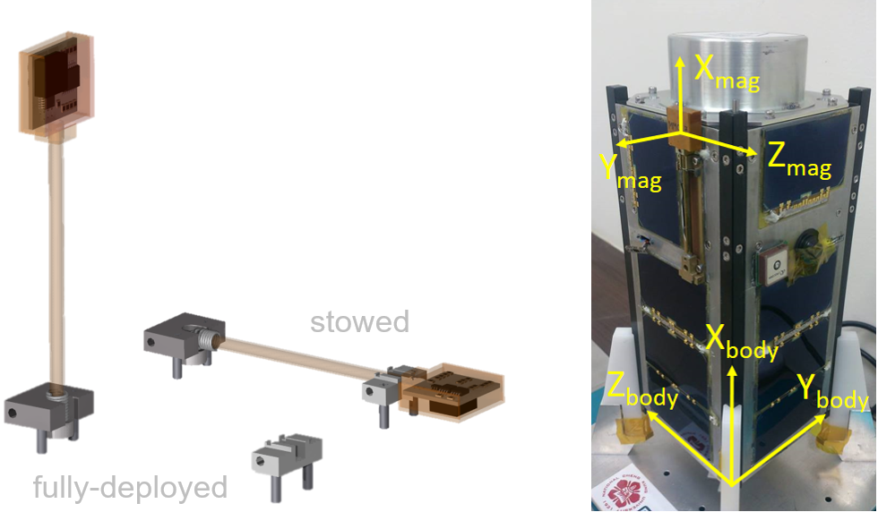

Figure 4‑1 3-axis Magnetometer (left) and Coordination Definition (right)

For the ADCS of PHOENIX, a rotation matrix is required to transform the magnetometer measurements from the raw 3-axis data, *Braw*, in the sensor-body frame to the calibrated data, *Bcalib*, in satellite-body frame. The magnetometer calibration equation adopted for ADCS [10] is defined as:

 (4.1)

and

 (4.2)

 (4.3)

where **M***mount* is a 3 × 3 mounting transformation DCM, **A** is a 3 × 3 sensitivity matrix, which includes scale factors and misalignment terms, and **d** is a 3 × 1 bias vector. Moreover, **M***mount*, **A** and **d** are adjustable through the tele-commands [10]. The calibrated measurements, *Bcalib*, will be applied for the estimation algorithms and control laws. On the other hand, raw measurements, *Braw*, will be primarily applied for the calibration. It can be found that there are no temperature-dependent terms adopted for the calibration model on-board, which means the calibrated measurements will be naturally influenced by the temperature variation. Therefore, to deal with the magnetometer without the correction with temperature compensation, a suboptimal solution will then be carried out in the later section.

### Thermometers of PHOENIX

For PHOENIX, there is no temperature sensor placed within the vicinity of the magnetometer, the locations and readings of accessible thermometers placed on four specific boards and modules are shown in Figure 4‑2 and Figure 4‑3.

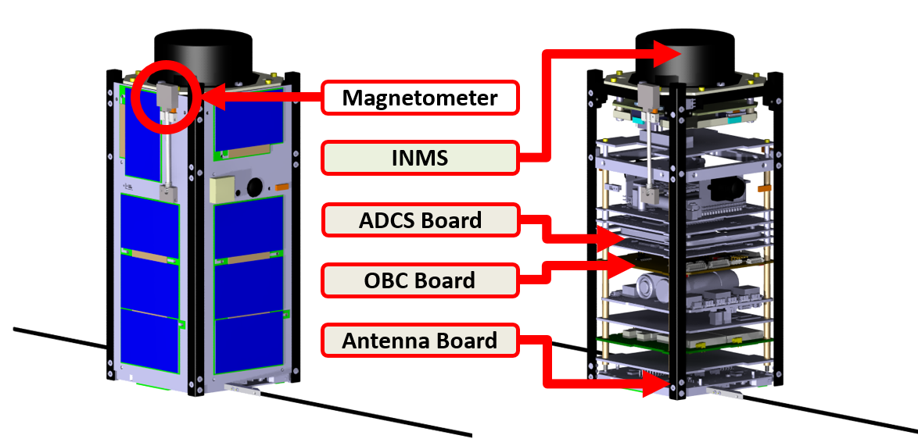

Figure 4‑2 Locations of Accessible Thermometers



Figure 4‑3 In-Flight Temperature Measurements

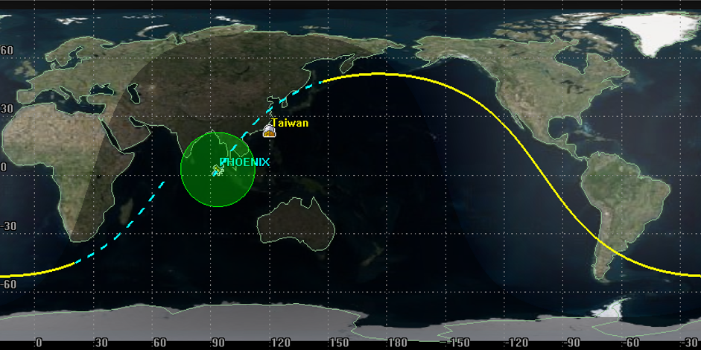

Figure 4‑4 Sunlit/Eclipse Part of the Orbit

Figure 4‑4 shows one of PHOENIX’s orbit, which includes sunlit part (solid yellow line) and eclipse part (dash blue line). The shadow areas in Figure 4‑3 represent that PHOENIX was in the eclipse parts of the orbits. In Figure 4‑3, four thermometers placed on different parts of PHOENIX reflect periodical variation, which are related to the thermal radiation and heat dissipation in both sunlit and eclipse parts of orbits.

Moreover, internal temperature measurements (in OBC and ADCS boards) perform delayed increase of temperature when getting into sunlit parts of the orbits due to the indirect effect of thermal radiation. In contrast, measurements, which are close to the outer panels (temperature in antenna board and INMS module), are more sensitive to the influence of thermal radiation when orbiting around the earth. In addition, it should be noted that the magnetometer is attached to one of the side panels in –Y direction within an aluminum enclosure, which means it can be expected that the change of temperature on the magnetometer will be more similar to the temperature measurements close to the outer panels.

Without the exact information of temperature on the magnetometer, to study the temperature-dependency of the magnetometer measurements, those indirect temperature information will be experimentally applied to the magnetometer calibration.

### IGRF Model

Besides, the geomagnetic field model is required as the reference for the magnetometer calibration. Here, an analytic model, international geomagnetic reference field (IGRF) model, is considered to provide the magnitude of the reference magnetic field. With the “time” which magnetometer measurement is sampled, the corresponding position of the satellite can be propagated and derived with the updated two-line-elements (TLEs) provided by NORAD. As a function of location, corresponding geomagnetic field in specific reference frame can then be calculated. The mathematical representation of IGRF model can be found in [7] and [8]. In this thesis, with the help of the software, System Tool Kit (STK), the magnitude of reference magnetic field can be directly calculated with the input of time array from the in-flight data [32].

In addition, the accuracy of the IGRF model under the nominal condition is expected to be approximately the order of 10 nT, which is much better than the typical ADCS-used magnetometers [17]. The most possible error is caused by the time offset between the actual time which the measurement is sampled and the tagged time in data file. For PHOENIX, it has been found that the time in OBC will delay about 1 sec. every 2 hours. Figure 4‑5 shows a long period of observation of the time delay between the OBC time tagged in the telemetry and the actual time the telemetry is received and decoded by the computer in ground station. Also, Figure 4‑6 shows more concrete presentation of the time information in SCS communication software. As a result, incorrect geomagnetic reference field will be applied and cause the additional calibration error. Figure 4‑7 shows the change of magnitude of the geomagnetic-reference field every 1 sec. intervals during an orbit.

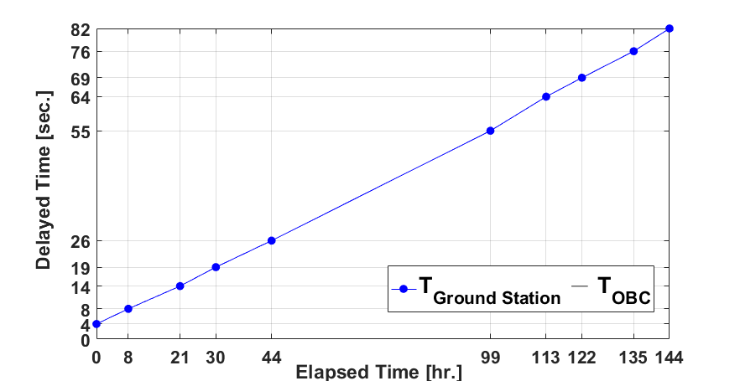

Figure 4‑5 Observation of Delayed OBC Time

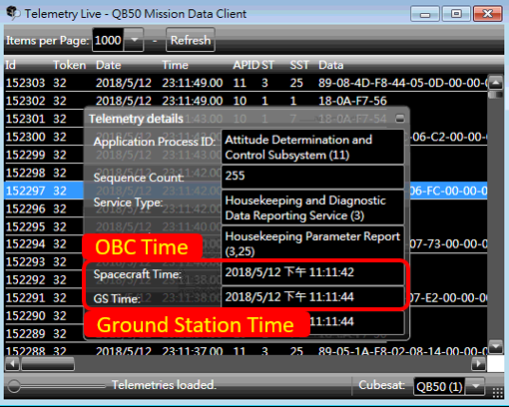

Figure 4‑6 Time Information in SCS Communication Software

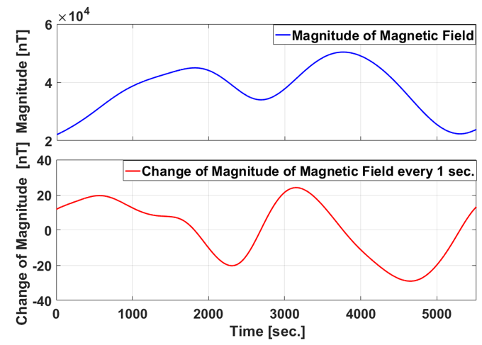

Figure 4‑7 Change of Magnitude of Magnetic Field every 1 sec.

It can be found that the error caused by the delayed OBC time may result in the worse performance of magnetometer calibration if the larger time offset exist. However, this uncertainty and error can be mitigated by synchronizing the time on-board regularly and shifting the time in the data file to find the proper corresponding geomagnetic-reference field. In this thesis, in-flight data will be collected and tagged with the updated OBC time initially, and the time offset is expected to be lower than 5 seconds, which will be post-corrected by adjusting the time series in the data file properly.

### In-Flight Data Collection

In-flight data will be collected under the scenario of no attitude control applied with mild tumbling (2~3 deg./sec.), in which the uncertainties of magnetic-coupling effect from magnetorquers can be ignored. Most importantly, solar radiation will be distributed averagely on each surface of satellite, then similar temperature behavior on the outer panels can be expected. Figure 4‑8 shows the schematic scenario of in-flight data collection.

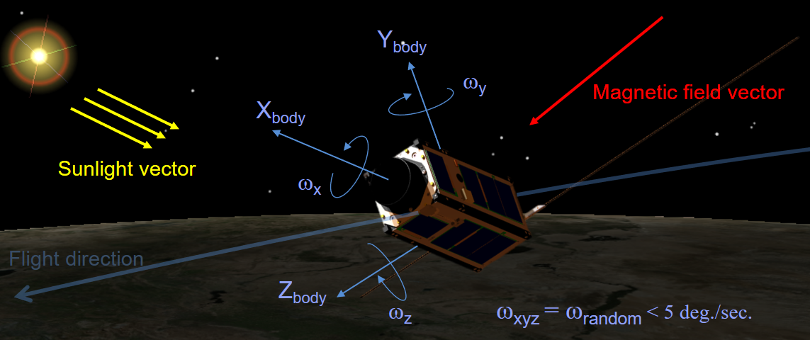

Figure 4‑8 Schematic Scenario of In-Flight Data Collection

In the sunlit parts of orbits, all the in-flight temperature measurements are related to the relationship between the unknown satellite attitude and sunlight vector as the highly complicated result associated with thermal radiation and thermal transfer. Meanwhile, it will produce more uncertainties to the calibration with the indirect temperature measurements, collected in the sunlit parts of orbits especially. Related study and verification will be carried out in the later sections.

Consequently, several batches of in-flight data are considered for the attitude-independent magnetometer calibration. For each batch of data, there are approximately 370 raw measurements of the 3-axis magnetometer and thermometers with 1 minute intervals (about 4 orbits in-flight data). Figure 4‑9 shows the magnitude of raw magnetometer measurements (blue line) and corresponding IGRF model (red line). Calibrated parameters need to be optimized to match the magnitude of calibrated measurements to the magnitude of geomagnetic reference field.

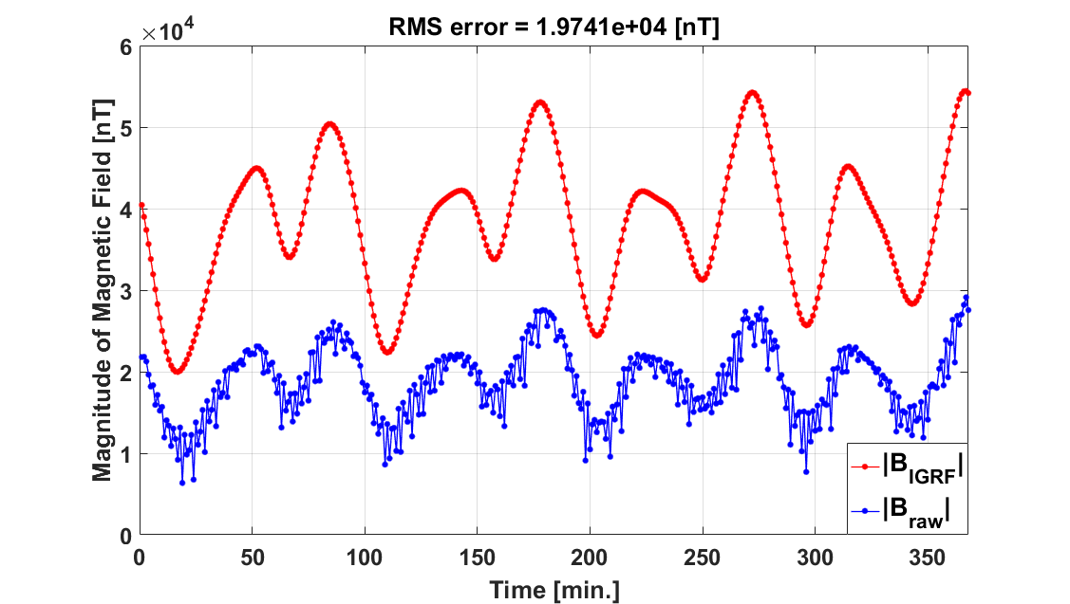

Figure 4‑9 Magnitudes of Raw Magnetometer Measurements and IGRF Model

## Ground-Calibration with In-Flight Data

There are two approaches for ground-calibration with in-flight data, magnetometer calibration utility in CubeSupport software, which is provided by QB50, and PSO-based magnetometer calibration developed by NCKU Space Lab. Both calibration methods are described and compared in the following sections.

### CubeSupport Calibration

Based on EKF attitude-independent magnetometer calibration [26], CubeSupport can estimate the optimal calibrated parameters with the inputs of magnetometer raw measurements, corresponding time tag and updated TLE [33]. Figure 4‑10 shows the graphic interface of the magnetometer calibration utility in CubeSupport, where the dark areas below mean the satellite was in the eclipse parts of orbits, and the blue and red line represent the magnitude of IGRF model and raw measurements, respectively.

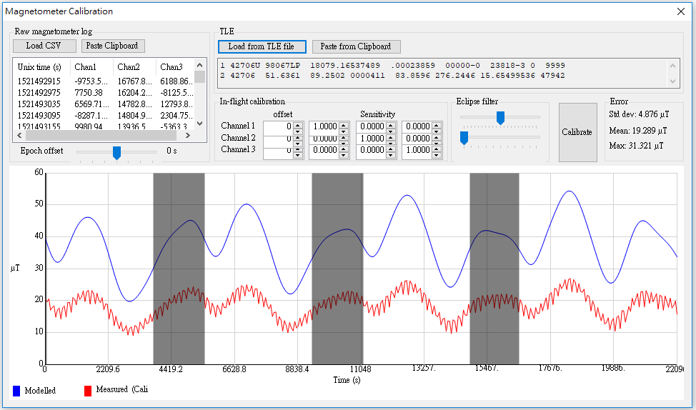

Figure 4‑10 Graphic Interface of Magnetometer Calibration in CubeSupport

The magnitudes of raw magnetometer measurements typically increase when the temperature increases. Therefore, to compensate the temperature-dependent errors, the magnitudes of IGRF model in the sunlit parts of orbits will be gradually amplified by adjusting the magnitude of amplitude and time-constant in the “Eclipse filter”. One can also change the TLE epoch offset in case the time tag of the measurements is not exactly synchronized. CubeSupport will show the results of error analysis on the panel, such as standard deviation, mean and maximum of error. Thus, optimal calibrated parameters can be obtained by manually adjusting the parameters mentioned above and re-calibrating until the calibration error is minimized. Figure 4‑11 shows the final result of in-flight calibration by CubeSupport, where only bias offset, scale factors and misalignment terms are estimated.

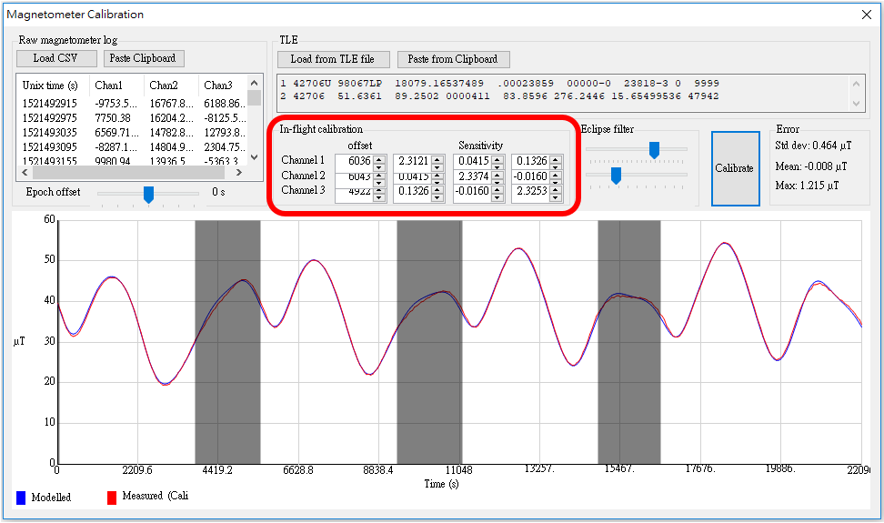

Figure 4‑11 Final Calibration Results from CubeSupport

### PSO-Based Calibration

PSO-based calibration is developed and conducted in the MATLAB environment. As mentioned in the previous chapters, the objective of PSO-based magnetometer calibration is to find the best calibrated parameters to minimize the RMS error between the magnitude of geomagnetic-reference vector from IGRF model and the calibrated magnetic field.

#### Initial Parameters Setting

According to temperature-dependent calibration model in Eq. (3.12) and Eq. (3.13), the position ***P****i* of each particle can be set and written as:

 (4.4)

which corresponds to sensitivity matrix **A***i* and bias offset **d***i* as below.

 (4.5)

 (4.6)

where the scalar term, *T*–*T*0, is assumed to be equal along 3-axis direction. It should be noted that the temperature reference *T*0 is adjustable, and the adequate setting will be discussed in the later section. Then, calibrated magnetic field can be obtained by Eq. (3.11). A total of 12 calibrated parameters subject to the fitness function in Eq. (3.29), and need to be optimized. In addition, with the knowledge from the pre-flight calibration and specification of the magnetometer, the boundary of the solution space can be estimated initially. The preliminary settings of *P*max and *P*min are specified as below.

 (4.7)

Particle swarm can then be initialized with **rand** function in MATLAB by Eq. (3.27). Figure 4‑12 shows the uniformly distributed positions of particles within the predefined boundary.

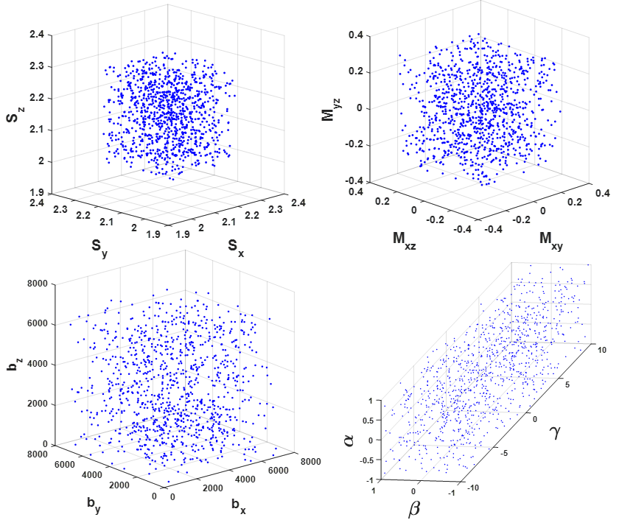

Figure 4‑12 Uniformly Distributed Positions of the Particle Swarm

Other relevant parameters for PSO-based calibration are listed in Table 4‑1 as below.

Table 4‑1 Parameters for PSO-Based Calibration

|  |  |  |
| --- | --- | --- |
| **Parameter** | **Value** | **Description** |
| *np* | 1000 | Size of particle swarm |
| *ns* | 12 | Dimension of the solution space |
| *V*lim | 100 | A constant for velocity limitation |
| *w* | 0.5 | Inertia weight |
| *c*1 | 1.5 | Cognitive learning rate |
| *c*2 | 1.5 | Social learning rate |
| *T*0 | 0 | Temperature reference [°C] |
| *k*max | 200 | Maximum number of iteration constraint |

#### Comparison Test

Besides, to demonstrate the improvement of calibration with temperature-dependent model, the calibration model below will be considered as a comparison test, which only consists of bias ***b***, scalar factors ***S*** and misalignment terms ***M***.

 (4.8)

Thus, the corresponding positions of particles can be defined as:

 (4.9)

Without terms for temperature correction, the comparison test will be performed by PSO-based calibration with the same setting of parameters mentioned in previous section.

#### Results of PSO-Based Calibration

Figure 4‑13 shows the magnitudes of calibrated measurements with different temperature measurements represented in Figure 4‑3 and the corresponding IGRF model (red-heavy line), and the calibration errors, |*B*IGRF|–|*Bcalib*|, are shown in Figure 4‑14.

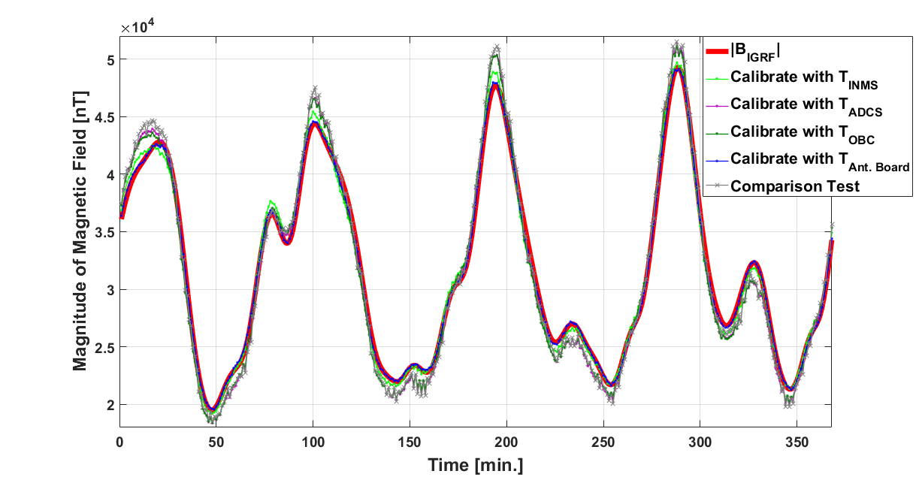

Figure 4‑13 Magnitudes of Calibrated Measurements

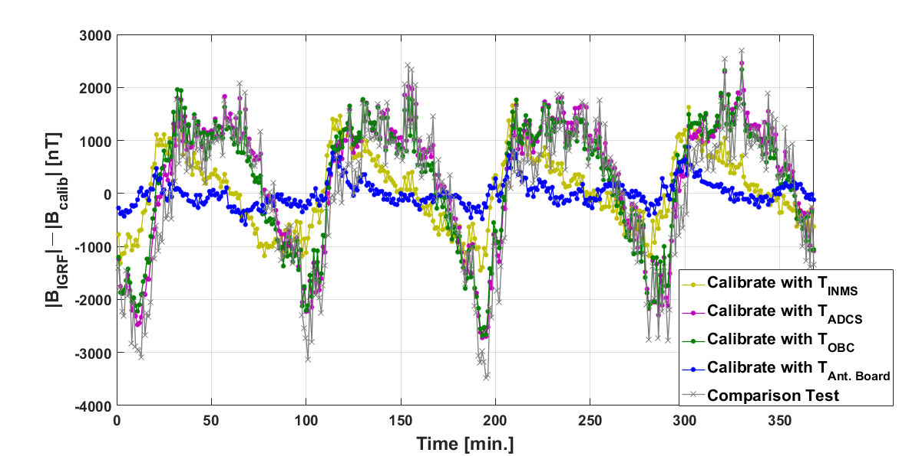

Figure 4‑14 Magnitude Errors of PSO-Based Calibration

Table 4‑2 Analysis of Errors in Figure 4‑14

|  |  |  |  |
| --- | --- | --- | --- |
| **Source** | **RMS [nT]** | **Mean [nT]** | **STD [nT]** |
| TINMS | 710 | 55.54 | 709 |
| TADCS | 1240 | 282.35 | 1209 |
| TOBC | 1194 | 249.33 | 1170 |
| TAnt. Board | 233 | -0.48 | 234 |
| Comparison Test | 1296 | 50.71 | 1297 |

Those errors are analyzed in Table 4‑2 above. To compensate the temperature-dependent effect, measurements of four thermometers mounted on different subsystems of PHOENIX are applied to the PSO-based magnetometer calibration experimentally. Obviously, one can observe the periodical change of errors, which is caused by the difference between the exact temperature of magnetometer and temperatures in other parts of satellite. For example, Figure 4‑15 shows the temperature difference between the measurements in the antenna board, TAnt. Board, and other temperature measurements, TINMS, TADCS and TOBC, and it can be found that there are the similar patterns as the calibration errors shown in Figure 4‑14. In addition, among four thermometers, calibration with temperature input, TAnt. Board, performs the minimum RMS error as presented in Table 4‑2, which means the characteristics of temperature measurements are more close to how exact temperature changes in the magnetometer.

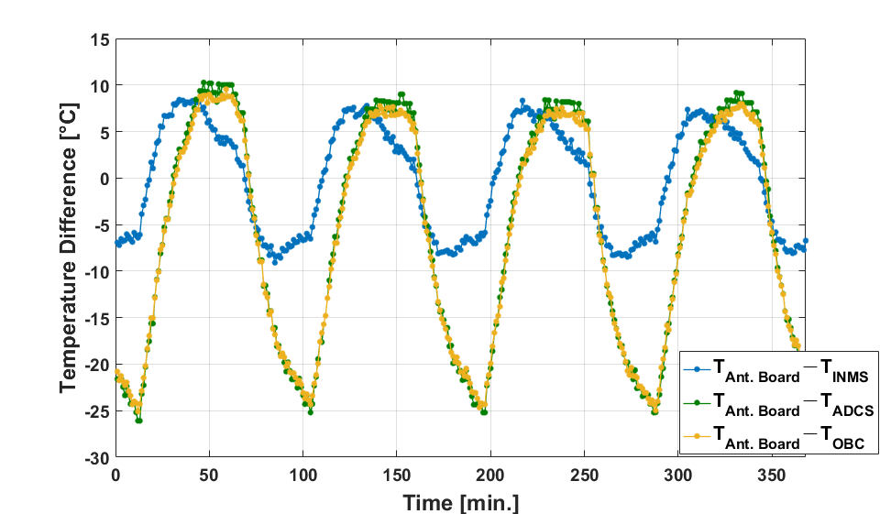

Figure 4‑15 Temperature Difference Compared with TAnt. Board

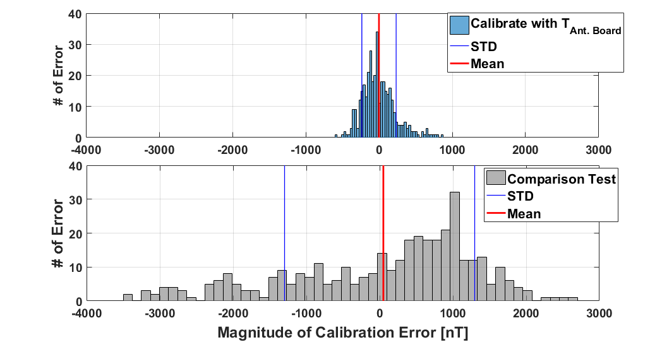

Figure 4‑16 Histogram of Errors of Calibration with TAnt. Board (Up) and

Comparison Test (Down)

Similar situations arise for the calibration without temperature-dependent model considered (comparison test), and its calibration error changes periodically as the errors of calibration with TADCS and TOBC as shown in Figure 4‑14. Moreover, Figure 4‑16 shows the histogram of calibration errors of the comparison test compared with the calibration with proposed temperature-dependent model and the input of indirect temperature, TAnt. Board. Obviously, there is a great improvement with the consideration of temperature-dependent model and input of temperature measurements in the antenna board especially.

On the other hand, Figure 4‑17 shows the final positions of particles, *Pi* (*k*max), after reaching the maximum iteration *k*max, and, initially, there are 1000 particles uniformly distributed within the range of predefined boundary (gray-small dots).

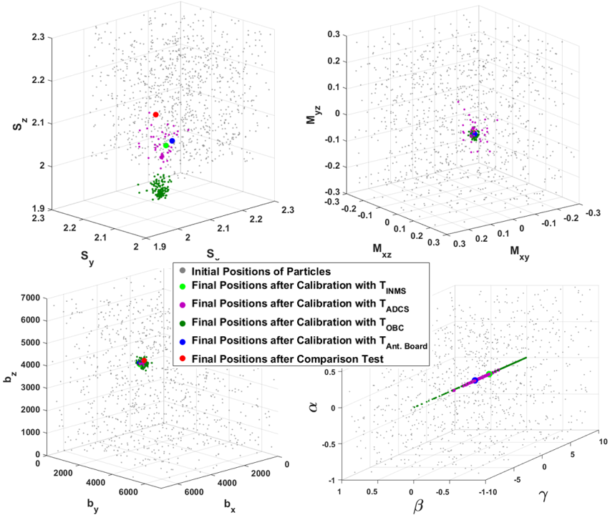

Figure 4‑17 Positions of Particles after PSO-Based Magnetometer Calibration

It can be observed that the result of final distribution of the particles is much smaller than the predefined boundary. Besides, the final particle swarms of each calibration scenario represent different particle distributions and convergence properties. Especially, the results of calibration with the specific temperature measurements, TADCS and TOBC, show the relative large scale of particle distribution compared to the calibration with TAnt. Board, TINMS and even the comparison test. It means the particles move in the larger region of the solution space that have similar fitness values and relative low RMS errors. Figure 4‑18 shows the RMS errors of the final particles after calibration with TADCS, which particles with similar RMS errors (dark-blue dots) are located within wider parameter range.

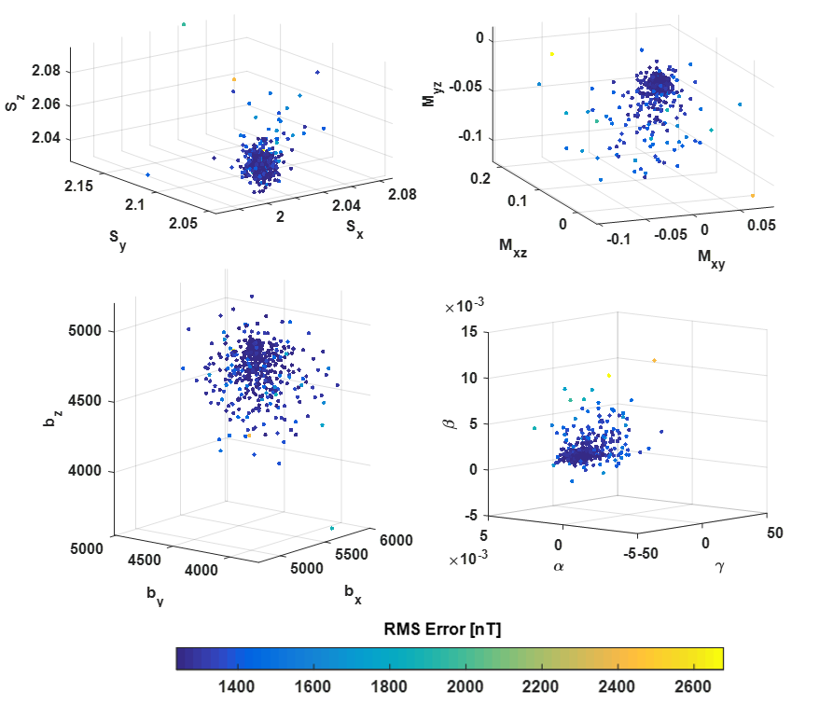

Figure 4‑18 RMS Errors of Final Positions of Particles after Calibration with TADCS

Consequently, Table 4‑3 below shows the calibrated parameters computed by PSO-based calibration with different temperature inputs and the comparison test. For some cases, the calibrated parameters of the global best, *Gbest*, are not located in the center of particle swarm. Overall, the estimations of scale factor, misalignment terms and bias have similar property about the sign of number and the order of magnitude in 3-axis.

Table 4‑3 Calibrated Parameters Computed by PSO-Based Calibration

|  |  |  |  |
| --- | --- | --- | --- |
| **Parameters** | *Gbest* (*k*max) | Mean(*Pi* (*k*max)) | STD(*Pi* (*k*max)) |
| **TINMS** | | | |
| [Sx, Sy, Sz] | [2.039, 2.079, 2.069] | [2.039, 2.079, 2.069] | [2.7, 3.7, 1.8]·10–10 |
| [Mxy, Mxz, Myz] | [0.035, 0.115, –0.017] | [0.035, 0.115, –0.017] | [5.8, 2.9, 2.6]·10–10 |
| [bx, by, bz] | [5793, 4460, 4753] | [5793, 4460, 4753] | [3.7, 3.2, 3.9]·10–6 |
| [*α*, *β*, *γ*] | [0.007, 8.9·10–5, 3.419] | [0.007, 8.9·10–5, 3.419] | [1.3, 1.5, 14950]·10–11 |
| **TADCS** | | | |
| [Sx, Sy, Sz] | [2.011, 2.064, 2.049] | [2.011, 2.063, 2.048] | [5.5, 6.6, 5.1]·10–3 |
| [Mxy, Mxz, Myz] | [0.030, 0.108, –0.022] | [0.025, 0.102, –0.028] | [1.4, 1.6, 1.4]·10–2 |
| [bx, by, bz] | [5663, 4488, 4818] | [5595, 4424, 4754] | [133, 134, 130] |
| [*α*, *β*, *γ*] | [0.004, 1.4·10–4, 3.116] | [0.004, 5.6·10–4, 7.236] | [3·10–4, 1·10–3, 7.9] |
| **TOBC** | | | |
| [Sx, Sy, Sz] | [1.948, 2.002, 1.988] | [1.950, 2.005, 1.990] | [9.6, 13.8, 12.9]·10–3 |
| [Mxy, Mxz, Myz] | [0.035, 0.112, –0.017] | [0.035, 0.112, –0.017] | [8.2, 7.2, 8.8]·10–3 |
| [bx, by, bz] | [5592, 4397, 4699] | [5610, 4415, 4717] | [41, 47, 50] |
| [*α*, *β*, *γ*] | [0.008, –2.1·10–4, 8.327] | [0.008, –1.5·10–4, 7.143] | [9·10–4, 5·10–4, 2.6] |
| **TAnt. Board** | | | |
| [Sx, Sy, Sz] | [2.063, 2.084, 2.073] | [2.063, 2.084, 2.073] | [0.9, 0.9, 2.0]·10–10 |
| [Mxy, Mxz, Myz] | [0.038, 0.121, –0.015] | [0.038, 0.121, –0.015] | [7.7, 6.6, 9.9]·10–11 |
| [bx, by, bz] | [5848, 4495, 4841] | [5848, 4495, 4841] | [1.7, 1.8, 1.2]·10–6 |
| [*α*, *β*, *γ*] | [0.007, 1.9·10–4, 0.907] | [0.007, 1.9·10–4, 0.907] | [7.7, 5.5, 69740]·10–12 |
| **Comparison Test** | | | |
| [Sx, Sy, Sz] | [2.073, 2.145, 2.119] | [2.073, 2.145, 2.119] | [7.1, 66.4, 9.0]·10–7 |
| [Mxy, Mxz, Myz] | [0.023, 0.094, –0.020] | [0.023, 0.094, –0.020] | [5.3, 1.6, 1.7]·10–6 |
| [bx, by, bz] | [5792, 4713, 4987] | [5792, 4713, 4987] | [0.136, 0.023, 0.047] |

Moreover, Figure 4‑19 shows the convergence of RMS errors of the *Gbest* (*k*) during each iteration. The large scale of predefined boundary of the temperature coefficients makes the bigger RMS errors initially, compared to the case of comparison test. After about 25 times of iteration, the RMS errors are converged to the constant values for each case. Finally, for the following in-flight verification, calibrated parameters computed by PSO-based calibration with input of TAnt. Board, which generally performs the minimum RMS error, will be majorly considered and implemented for PHOENIX CubeSat.

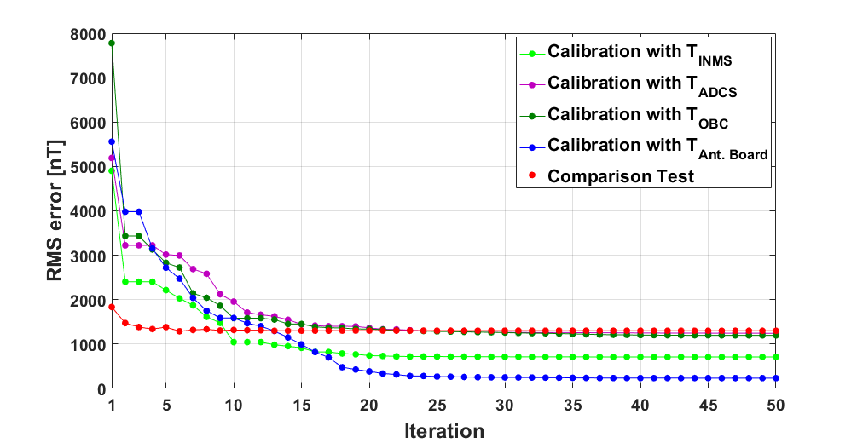

Figure 4‑19 RMS Errors of the *Gbest* in Each Iteration

To go a step further, Figure 4‑20 shows the mean with 1σ bounds of calibrated parameters after 50 runs of 200 iterations with 1000 particles considered (the initial positions of particles are different and randomly distributed for each run). Also, to study the performance of calibration with different sizes of particle swarms, 50 runs of 200 iterations with 100 and 50 particles are experimentally applied, and the results are shown in Figure 4‑21 and Figure 4‑22 respectively. Additionally, related studies are analyzed and listed in Table 4‑4.

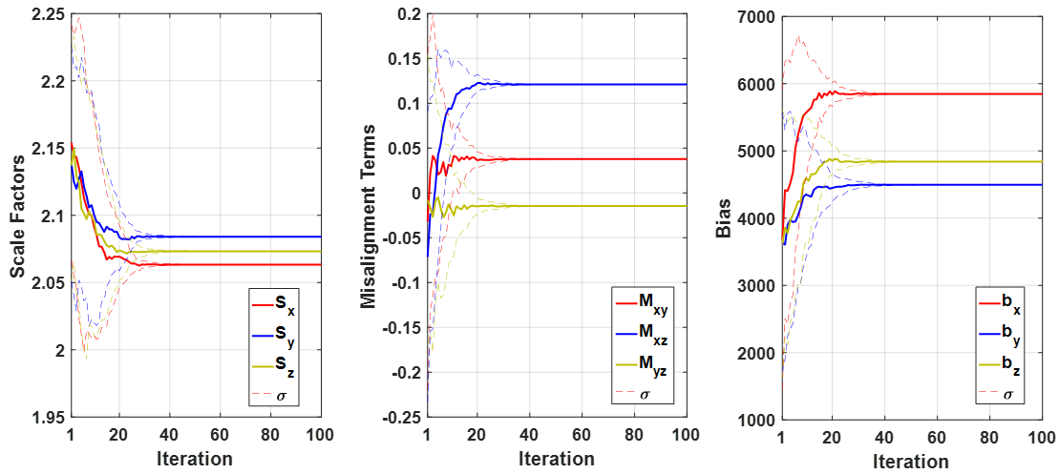

Figure 4‑20 Results of Calibrated Parameters with 1000 Particles

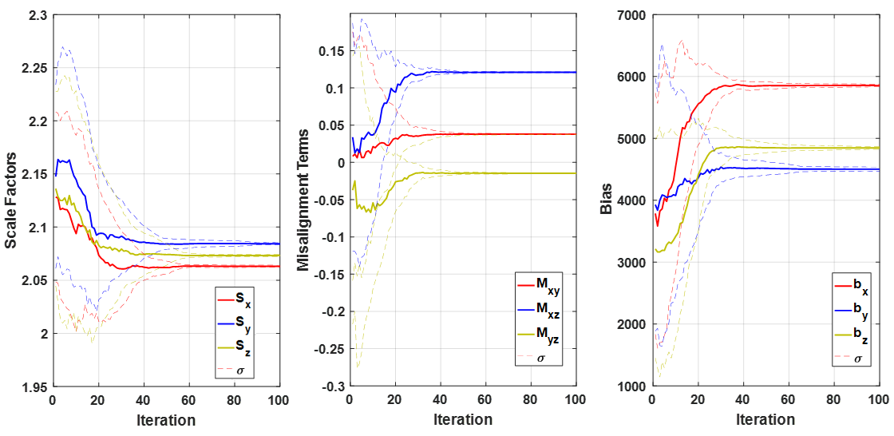

Figure 4‑21 Results of Calibrated Parameters with 100 Particles

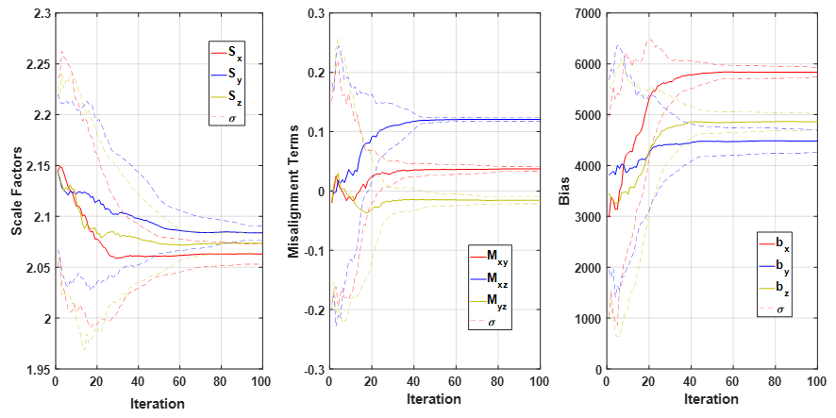

Figure 4‑22 Results of Calibrated Parameters with 50 Particles

Table 4‑4 Estimation of Calibrated Parameters with Different Sizes of Particle Swarm

|  |  |  |
| --- | --- | --- |
| **Parameter** | **Mean** | **3σ** |
| 1000 Particles | | |
| RMS Error | 233.69 [nT] | 5.1·10–13 [nT] |
| [*Sx, Sy, Sz*] | [2.063, 2.084, 2.073] | [1.9, 1.5, 1.7]·10–9 |
| [*Mxy, Mxz, Syz*] | [0.038, 0.121, –0.015] | [1.2, 1.0, 1.0]·10–9 |
| [*bx, by, bz*] | [5848, 4495, 4841] | [1.3, 2.1, 1.9]·10–5 |
| *α* | 0.0066 | 5.4·10–11 |
| *β* | 1.9·10–4 | 5.4·10–11 |
| *γ* | 0.907 | 8.0·10–7 |
| 100 Particles | | |
| RMS Error | 233.73 [nT] | 6.0·10–13 [nT] |
| [*Sx, Sy, Sz*] | [2.063, 2.084, 2.073] | [0.003, 0.003, 0.002] |
| [*Mxy, Mxz, Syz*] | [0.038, 0.121, –0.015] | [0.001, 0.001, 0.002] |
| [*bx, by, bz*] | [5852, 4498, 4844] | [42.4, 51.7, 46.4] |
| *α* | 0.0065 | 1.7·10–4 |
| *β* | 1.7·10–4 | 2.3·10–4 |
| *γ* | 0.576 | 3.914 |
| 50 Particles | | |
| RMS Error | 259.01 [nT] | 149.3 [nT] |
| [*Sx, Sy, Sz*] | [2.063, 2.084, 2.073] | [0.029, 0.015, 0.022] |
| [*Mxy, Mxz, Syz*] | [0.037, 0.121, –0.016] | [0.013, 0.008, 0.018] |
| [*bx, by, bz*] | [5845, 4498, 4843] | [184.5, 225.1, 300.0] |
| *α* | 0.0065 | 5.5·10–4 |
| *β* | 1.6·10–4 | 5.0·10–4 |
| *γ* | 0.242 | 9.746 |
| 10 Particles | | |
| RMS Error | 2370 [nT] | 2974 [nT] |
| [*Sx, Sy, Sz*] | [2.105, 2.097, 2.089] | [0.381, 0.311, 0.368] |
| [*Mxy, Mxz, Syz*] | [0.038, 0.053, –0.026] | [0.296, 0.367, 0.330] |
| [*bx, by, bz*] | [5241, 4263, 4125] | [4322, 5070, 3974] |
| *α* | 0.0051 | 0.0064 |
| *β* | 7.9·10–5 | 0.0052 |
| *γ* | 0.147 | 28.12 |

Consequently, based on 50 runs of 200 iterations, Figure 4‑23 shows the mean and standard deviation of calibration error with different sizes of particle swarms. The standard deviation is rapidly converged since the size of particle swarm is larger than 40, and the mean of RMS errors is gradually decreased and saturated, which the magnitude of variation in the RMS errors are lower than 1 nT if the number of particles is larger than 100. With the acceptable execution time, the calibrated parameters estimated with 1000 particles will be applied for the in-flight magnetometer calibration because of the more consistent results of estimation. Besides, the computation load and time-consuming process will not be the major concerns for ground-calibration especially, instead, it should be considered and mitigated for the real-time magnetometer calibration.



Figure 4‑23 RMS Errors with Different Sizes of Particle Swarms

## In-Flight Test of Calibrated Parameters

In this section, performance of ground-calibration will be tested with the new run of in-flight data. To directly evaluate the calibrated parameters, those will be uploaded to PHOENIX, which only include bias, scale factors and misalignment terms (PHOENIX has no mechanism of temperature compensation). Then, in-flight calibrated magnetometer measurements can then be collected, and complete verification can be done by re-calibrating with in-flight temperature measurements. To describe more specifically, Figure 4‑24 shows the flowchart of in-flight experiment with calibrated parameters estimated in the previous section.



Figure 4‑24 Flowchart of In-Flight Verification

Figure 4‑25 shows the magnitude of calibrated measurements without temperature compensation, with TAnt. Board re-calibration and with calibrated parameters computed from the comparison test, respectively. The magnitude errors are shown in Figure 4‑26 and analyzed in Table 4‑5. Besides, Figure 4‑27 shows the in-flight temperature measurements for the re-calibration.



Figure 4‑25 | *Bcalib* |with Different Configurations



Figure 4‑26 Norm Residuals of | *Bcalib* | with Different Configurations

Table 4‑5 Analysis of Errors in Figure 4‑26

|  |  |  |  |  |
| --- | --- | --- | --- | --- |
| **Case** | **Source** | **RMS [nT]** | **Mean [nT]** | **STD [nT]** |
| 1. | w/o Temp. Compensation | 2715 | 2458 | 1154 |
| 2. | w/ TAnt. Board | 949 | 622 | 718 |
| 3. | w/ Comparison Test | 2187 | 1823 | 1210 |



Figure 4‑27 In-Flight Temperature Measurements

Firstly, for the calibration without temperature compensation, fixed bias, scalar factors and misalignment terms primarily make the magnitude errors greatly change with not only actual temperature in the magnetometer but also the magnitude of the true magnetic field, then result in the periodical errors with the specific pattern. On the other hand, for Case 2, the result of re-calibration with temperature, TAnt. Board, shows larger RMS error than result of ground-calibration in the previous section. It’s not only the issue of non-global optima estimated by the PSO-based calibration, but also the concern about the indirect temperature input for temperature-dependent model. The relation between the exact temperature in the magnetometer and temperatures in other parts of satellite is highly complicated and even attitude-related. For example, Figure 4‑28 shows the in-flight temperature measurements collected with very slow tumbling rate (< 1 deg./sec.). It can be found that the change of temperature, TAnt. Board, is more irregular than the ones shown in Figure 4‑3 and Figure 4‑27.



Figure 4‑28 In-Flight Temperature Measurements under Very Slow Tumbling

Therefore, it means the estimated parameters may suffer from the uncertainty of the hardly observable transformation from the indirect temperature measurements (TAnt. Board) to the exact temperature measurements (TMagnetometer), then result in the specific optima for the calibration with specific batch of data. Consequently, the calibration with different batches of data input may shows not only variable temperature coefficients but also inconsistent terms of bias, scale factors and misalignments terms.

Furthermore, take the comparison between the performances of the fixed bias, scale factors and misalignment terms estimated from the calibration with indirect temperature measurements (Case 1) and the comparison test (Case 2), the latter one shows larger scale of jittering points in Figure 4‑26. Those jittering points are caused by errors in calibrated parameters with different attitude states of satellite. Because parameters in Case 1 are optimized with the consideration of filtering the temperature-dependent characteristics, it performs more robustly than Case 2 under the same effect of temperature variation.

Eventually, the in-flight experiment basically shows the improvement with temperature compensation in spite of the indirect temperature measurements experimentally applied. The uncertainty in calibration with indirect temperature measurements can be addressed if exact temperature measurements in the magnetometer are available. In addition, for magnetometers without mechanism of temperature compensation, further studies to find better calibrated parameters will be presented in Section 4.4.

## Further Study of Magnetometer Calibration

This section gives the further studies about in-flight magnetometer calibration. Based on the observation of behavior of in-flight temperature measurements, several experiments will be implemented to find the better calibration performance in different angles, which are described in the following subsections.

### The Setting of Temperature Reference *T*0

For in-flight magnetometer calibration without temperature compensation, magnitude of calibrated measurements will be influenced by the periodical errors of temperature-dependent terms during the variation of in-situ temperature. However, the magnitude of those terms can be gradually reduced if the temperature inputs are close to the pre-defined *T*0 according to the term, *T*–*T*0, in the calibration model. Therefore, to find a suboptimal solution for magnetometers without considering temperature-dependent model, it can be achieved with a proper setting of temperature reference *T*0. Moreover, in order to simulate the condition of no temperature compensation, the magnitudes of temperature dependent terms will be considered as the calibration errors.

Figure 4‑29 shows the norm residuals of calibration with different settings of *T*0, which include the magnitudes of temperature dependent terms for each. Those errors are analyzed and listed in Table 4‑6.



Figure 4‑29 Norm Residuals of | *Bcalib* | with Different Settings of *T*0

Table 4‑6 Analysis of the Errors in Figure 4‑29

|  |  |  |
| --- | --- | --- |
| ***T*0** | **RMS [nT]** | **# of Magnitude of Errors < 1000 nT** |
| –10 | 3880 | 0 % |
| 0 | 2715 | 13 % |
| 10 | 1647 | 31 % |
| 20 | 1046 | 67 % |
| 30 | 1588 | 64 % |

Based on the linear temperature-dependent calibration model, different settings of *T*0 can get the corresponding values of ***S***0, ***M***0 and ***b***0, and result in different performances of temperature-dependent errors. Here, among the five settings of *T*0 in Figure 4‑29, blue line, *T*0 = 20 °C, is viewed as the best solution, because it performs the minimum RMS error and the larger proportion of acceptable magnitudes of errors. It should be noted that the corresponding settings of temperature reference *T*0 with the minimum RMS error and the maximum proportion of acceptable magnitudes of errors are different. Figure 4‑30 below shows the error analysis with different settings of *T*0. Therefore, for magnetometers without temperature compensation, the setting of temperature reference *T*0 can provide the flexibility to make the proper decision between the desired RMS error and the expected proportion of acceptable magnitudes of errors.



Figure 4‑30 Error Analysis with Different Settings of Temperature Reference *T*0

#### Comparison with Results from CubeSupport

Magnetometer calibration utility in CubeSupport software only provide the constant calibrated parameters such as bias, scale factors and misalignment terms, which the effect of temperature-dependent error is still expected. However, for CubeSupport calibration, the temperature-dependent errors are considered and mitigated by the manual adjustment of the magnitude of geomagnetic-reference field as described in Section 4.2.1.

It has been found that similar calibration performance can be achieved by the proposed method with proper setting of temperature reference *T*0. Figure 4‑31 shows the calibration errors with the calibrated parameters computed by CubeSupport and the proposed method with the setting, *T*0 = 27 °C. The calibrated parameters are shown in Table 4‑7.



Figure 4‑31 Norm Residuals of | *Bcalib* | with Parameters from CubeSupport and PSO

Table 4‑7 Calibrated Parameters from CubeSupport and PSO

|  |  |  |
| --- | --- | --- |
|  | **PSO with T0 = 27 °C** | **CubeSupport** |
| Scale Factors | [2.240, 2.261, 2.250] | [2.237, 2.261, 2.251] |
| Misalignment | [0.042, 0.126, –0.009] | [0.042, 0.129, –0.016] |
| Bias | [5872, 4519, 4866] | [5874, 4476, 4859] |

Considering the effect of temperature-dependent errors, both calibration methods result in matched patterns of errors and similar RMS values. For PHOENIX, the proposed method gives an insight into the relationship with the real temperature measurements on-board. In addition, it also gives the possible reason for the requirement of magnetometer calibration as a regular work for PHOENIX (especially for magnetometers without temperature compensation). Because the distribution of the temperature variation in space will vary with the change of “beta angle”, which effects the proportions of sunlit and eclipse duration in each orbit. Figure 4‑32 shows the long duration of in-flight temperature measurements (a total of 52 packets of in-flight data) and the corresponding magnitude of beta angle. It can be observed that the minimums of each temperature measurements approximately match with the variation of beta angle. Therefore, the setting of temperature reference *T*0 should be adjusted as the change of in-flight temperature distribution.

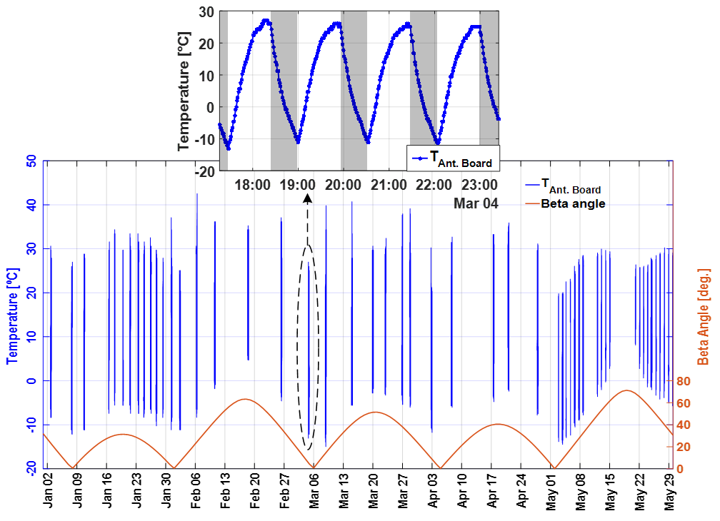

Figure 4‑32 Long Duration of Beta Angle and In-Flight Temperature Measurements

### Analysis of PSO-Based Calibration

#### Different Setting of Initial Boundary

This section will study the degree of dependence of PSO-based calibration on the setting of initial boundary. Generally, nominal calibrated parameters can be acquired from the magnetometer manufacturer. The default calibrated parameters of the magnetometer for PHOENIX are shown in Figure 4‑33. The scale factors are 2 in 3-axis and other terms are 0, but all of the calibrated parameters should be adjusted via the proper calibration.

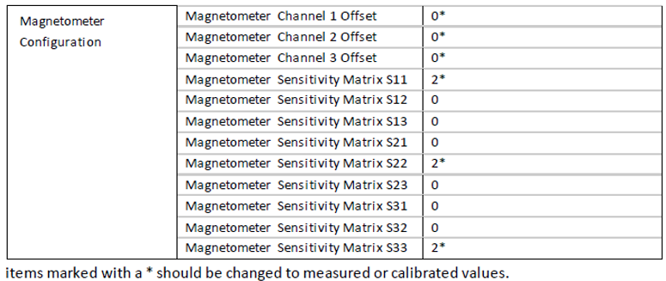

Figure 4‑33 PHOENIX’s Magnetometer Configuration [10]

Here, based on those nominal values, different settings of initial boundary for PSO-based calibration are experimentally set in Table 4‑8.

Table 4‑8 Initial Boundary Settings [min, max]

|  |  |  |  |
| --- | --- | --- | --- |
|  | 1. **Small Range** | 1. **Large Range** | 1. **Out of Range** |
| Scale Factors | [1.8, 2.2] | [1, 3] | [1.5, 1.8] |
| Misalignment | [–0.2, 0.2] | [–0.5, 0.5] | [–0.5, –0.3] |
| Bias | [–6000, 6000] | [–12000, 12000] | [–4000, –1000] |
| ***α*** | [–0.1, 0.1] | [–1, 1] | [–0.8, –0.5] |
| ***β*** | [–0.1, 0.1] | [–1, 1] | [–0.8, –0.5] |
| ***γ*** | [–20, 20] | [–100, 100] | [–100, –50] |

There’re three cases considered. The first and second cases are centered around the nominal values with small and large range respectively, while the third case considers the misestimate that the nominal values are out of the initial boundary. Figure 4‑34 and Figure 4‑35 show the results after 50 runs with each condition setting.



Figure 4‑34 Results of 50 Runs with Each Case Considered



Figure 4‑35 Distributions of Final Results after 50 Runs

After 50 runs of PSO-based calibration with different settings of initial boundary, the parameters with the minimum fitness value (RMS error) were found to be within both small and large range of initial boundary. The 50 runs of calibration with small-range initial boundary perform quite consistent results as well as the values of calibrated parameters. For the second case, the initial RMS errors for each run are generally larger than the first case, then finally, about 41 runs get the similar results as the first case. Lastly, for the third case, only 8 runs achieve the lowest fitness value, while most of the runs result in the larger RMS errors compared with other two cases. Overall, after 50 runs with different initial boundary, the calibrated parameters with the minimum fitness value are consistent, which are viewed as the global optima. However, the solution-search capability of PSO-based calibration will be affected by the size and region of initial boundary, and may result in local optima and poor fitness value for some runs. Table 4‑9 shows the performance analysis of results after 50 runs for each case. In addition, there’re some runs finally perform acceptable fitness values (RMS Error < 1000 nT), but the calibrated parameters are illogical (much different from the nominal value), for example, shown in Table 4‑10.

Table 4‑9 Analysis Results after 50 Runs for Three Cases

|  |  |  |
| --- | --- | --- |
|  | **Final RMSE < 1000 nT** | **# of Global Optima** |
| Small Range | 50/50 | 50/50 |
| Large Range | 42/50 | 41/50 |
| Out of Range | 12/50 | 8/50 |

Table 4‑10 Calibrated Parameters of Two Runs with Acceptable Fitness

|  |  |  |
| --- | --- | --- |
|  | **Rational: RMSE = 234 nT** | **Illogical: RMSE = 325 nT** |
| Scale Factors | [2.063, 2.084, 2.073] | [–0.070, 1.950, –0.039] |
| Misalignment | [0.038, 0.121, –0.015] | [–0.510, –1.996, –0.559] |
| Bias | [5848, 4495, 4841] | [–5566, 1421, –6550] |
| ***α*** | 0.0066 | 0.0019 |
| ***β*** | 1.9·10–4 | –0.0058 |
| ***γ*** | 0.907 | –12.05 |

It can be found that the most illogical term is the sensitivity matrix (composed of scale factor and misalignment terms). Consequently, for the case of illogical calibrated parameters with acceptable fitness value, those ambiguous results should be post-filtered with additional constraints on the parameters. On the other hand, for the second and third cases, the solution-search capability may be promoted by increasing the size of particle swarm according to the test in the last part of Section 4.2.2.3, which will increase the execution time as well. The following section will discuss another feasible method to tackle this issue.

#### Dynamic Weighting Parameters

These weighting parameters play an important role for global solution searching and convergent performance. Therefore, to improve the performance of PSO-based calibration with the weak initial boundary, dynamic weighting parameters are considered. Figure 4‑36 shows the original setting of each weighting parameters, inertia weight *ω* and cognitive and social learning rate, *c*1 and *c*2 respectively.



Figure 4‑36 Original Setting of Weighting Parameters

The original purpose of this setting is to find the solution within the predefined search space with good convergent performance over the iterations. It’s for the case that the setting of initial boundary is reliable based on empirical evidence and sensor specification.

Figure 4‑37 below shows the setting of dynamic weighting parameters, the weighting parameters are changed with the iteration progress. Based on similar setting in [30], to extend the exploration of search space, inertia weight *ω* is designed as a descendent function from a larger initial value, then all the parameters are set as the original setting to converge and prevent particles from stagnating in local minima. Figure 4‑38 shows the distribution of final results after 50 runs of each case with the dynamic weighting parameters.



Figure 4‑37 Setting of Dynamic Weighting Parameters



Figure 4‑38 Distributions of Final Results after 50 Runs with Dynamic Weightings

Table 4‑11 shows the performance analysis of results after 50 runs of each case with dynamic weighting parameters. For the case of the boundary condition that does not contain the global optima, larger inertia weight and relative lower social learning rate in the early stage encourage particles to expand the space of exploration beyond the initial limits. Therefore, for the third case, the evident improvement for the runs, which achieve the global optima, can be observed because of the promoted probability for searching global optima outside the boundary. The better searching ability also help particles in finding lower fitness values from the poor initial positions. However, for the third case, the chance of reaching the global optima is not always guaranteed. Because the movements of particles depend on the larger momentums that stochastically push the particles outside the boundary, and global optima can only be approached if some particles move across the proper solution region.

Table 4‑11 Analysis Results after 50 Runs of Three Cases with Dynamic Weightings

|  |  |  |
| --- | --- | --- |
|  | **Final RMSE < 1000 nT** | **# of Global Optima** |
| Small Range | 50/50 | 50/50 |
| Large Range | 47/50 | 37/50 |
| Out of Range | 43/50 | 21/50 |

Consequently, this investigation significantly presents the dependence of the global convergence of PSO-based calibration on the setting of initial boundary. Moreover, it also enhances the trust in correctness of calibrated parameters as those values are the global minima for all the three cases. It should be noted that, in fact, the settings of second and third case are out of practical application for magnetometer calibration, and PSO-based calibration with dynamic weightings still provides the most of the solutions with acceptable fitness value. Those solutions, which are not the expected global optima, represent the potential possibility of calibrated parameters in the case if there is no actual information and knowledge about those parameters.

# Conclusions and Future Works

This study gives an insight into magnetometer calibration with its temperature-dependent property. For small satellites and CubeSats that rely on the application of magnetometers, and even magnetometers without the mechanism of temperature compensation, the proposed approach is believed to provide improved and robust calibration performance under the scenario of various temperature conditions during orbiting the earth.

## Discussions

* ***Importance of In-Flight Magnetometer Calibration***

In-flight magnetometer calibration acts as a core role for CubeSats, which mainly rely on the magnetic field measurements to calculate the control commands and attitude states. Based on the operation experience of PHOENIX CubeSat, it has been found that the accuracy of calibrated parameters will affect the performance of attitude control and determination. Therefore, both pre-launch and post-launch calibration should be highly regarded and cautiously conducted.

* ***Calibration with Temperature Compensation***

To fully accomplish the proposed in-flight magnetometer calibration, raw measurements of magnetic field, actual temperature measurements in the magnetometer and the corresponding magnitude of the IGRF model are required. However, due to the lack of magnetometer’s temperature information, indirect temperature measurements are experimentally applied as the inputs to the proposed calibration method. The calibration results perform the significant improvement in comparison with no temperature-dependent terms are considered (comparison test). Nevertheless, the calibration with the inputs of indirect temperature measurements still remains uncertainty in the estimation of calibrated parameters, which affects the performance of in-flight test. From the results of in-flight test, magnitude errors of re-calibrated measurements are inconsistent with the expected results from the ground calibration. However, it should be noted that the terms of bias, scale factors and misalignment terms from proposed calibration method still show more robust performance in comparison with parameters from the comparison test. Further complete analysis of in-flight verification can be achieved if exact temperature measurements in the magnetometer are available.

* ***Suboptimal Solution for Magnetometers without Temperature Compensation***

Another contribution of this thesis is to find the suboptimal solution for satellites with magnetometers without the mechanism of temperature compensation. Based on the analysis of different settings of temperature reference *T*0 in the calibration model, corresponding settings to minimize the RMS error and to maximize the percentage of errors within the predefined range can be found. With proper setting of *T*0, it should be noted that the performance is much better than both results of re-calibration and comparison test in the in-flight test. Also, similar performance can be achieved as the results from magnetometer calibration utility in the CubeSupport software. For magnetometers without the temperature compensation, this study also gives an explanation for the need of routine calibration with the long duration of observation about the temperature behavior in orbit.

* ***PSO-based Calibration***

PSO-based calibration shows several advantages such as fast implementation, convergence-guaranteed capability with different settings of initial boundary and the flexibility for various definitions of fitness function. In addition, optimal calibrated parameters can be computed directly without complicated transformation from the intermediate variables. In this thesis, the performance of PSO-based calibration shows the dependence of solution-search capability on the size of particle swarm, while the time-consuming issue may arise if larger size of particle swarm is considered. The calibrated parameters from the PSO-based calibration shows similar results as ones from CubeSupport (EKF-based). Also, the calibrated parameters are later confirmed to be the global optima from the results of calibration with three different settings of initial boundary condition.

## Future Works

Finally, some recommendations for the future researches are listed as follow.

* ***Parallel Computation of PSO-based Calibration***

To reduce the computation time of PSO-based calibration, parallel computation is a good starting point to be implemented [44]. For the larger size of particle swarm, dimension of solution space and number of iteration, GPU-parallelized framework can be further developed to improve both the calibration performance and the time taken.

* ***Real-Time In-Flight Magnetometer Calibration***

For a better design of CubeSat in the future, a function of real-time in-flight magnetometer calibration can make the mission operation go smoothly and automatically, and also accelerate the process of magnetometer calibration [26] [27][28]. This function should be cautiously verified and assessed on ground. Most importantly, it should be designed as one of optional modes in the case of any unexpected circumstances.

* ***Hardware-in-the-Loop Verification***

To actually verify the in-flight magnetometer calibration on ground, HIL can provide the possibility of both environment simulation and method validation.

Firstly, to simulate the scenario of torque-free tumbling, 3-degrees-of-freedom (3-DoF) air-bearing platform is required, shown in Figure 5‑1. Here, it should be noted that the center of mass should be adjusted to locate at the center of the spherical platform.

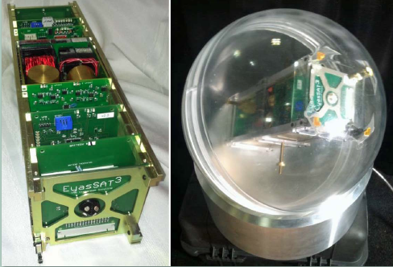

Figure 5‑1 3-DoF Air Bearing Platform (right) [45]

On the other hand, to simulate the magnetic field in orbit, software should be developed to propagate the position of satellite and compute the magnetic field in the reference frame with IGRF model. Meanwhile, the calculated 3-axis magnetic field is viewed as the desired output of the “closed-loop” 3-axis Helmholtz coil cage, shown in Figure 5‑2. It can produce the desired 3-axis magnetic field and control the current outputs with the feedback from a calibrated magnetometer sensor at the center of cage.

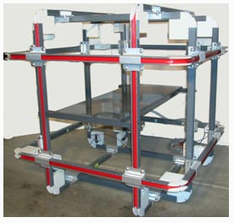

Figure 5‑2 3-axis Helmholtz Coil Platform [46]

The overall system structure diagram is shown in Figure 5‑3.



Figure 5‑3 HIL System Structure

With HIL simulation, the magnetometer measurements and temperature information under the scenario of no control applied can be collected, then proposed calibration method can be verified on ground. Most importantly, the aforementioned real-time in-flight calibration and ADCS-related researches can also be tested and verified with the assistance of HIL facilities [48].

# References

[1] QB50 Website, Available: <http://www.qb50.eu>, Accessed in 2018.

[2] C. Underwood, “Development of the InflateSail (QB50 GB06) 3U CubeSat Technology Demonstrator and First Flight Results,” in *9th European CubeSat Symposium*, Belgium, 2017.

[3] T. C. Huang, *Implementation and Verification of Reliable Flight Software for CubeSats*, M.S. Thesis, Department of Electrical Engineering, National Cheng Kung University, 2016.

[4] C. H. Yeh, *Estimation of Power Behavior in PHOENIX’s Electrical Power Subsystem*, M.S. Thesis, Department of Electrical Engineering, National Cheng Kung University, 2017.

[5] J. C. Liu, *Mission Planning System for an Atmospheric Resarch CubeSat*, M.S. Thesis, Department of Electrical Engineering, National Cheng Kung University, 2017.

[6] T. Y. Lin, *Design and Verification of the Control Procedure of Attitude Determination and Control Subsystem for Nanosatellite*, M.S. Thesis, Department of Electrical Engineering, National Cheng Kung University, 2014.

[7] Vina, *Attitude Determination and Control Subsystem for PHOENIX CubeSat: Design, Implementation and Testing*, M.S. Thesis, Department of Electrical Engineering, National Cheng Kung University, 2015.

[8] S. H. Wu, *Operating Strategy in PHOENIX’s Attitude Determination and Control Subsystem*, M.S. Thesis, Department of Electrical Engineering, National Cheng Kung University, 2016.

[9] L. Visagie and M. A. Kearney, “ADCS Interface Control Document ver. 3.2,” Surrey Space Centre, 2015.

[10] L. Visagie, “QB50 ADCS Reference Manual ver. 2.0,” Surrey Space Centre, 2015.

[11] L. Visagie, “QB50 ADCS Commissioning Manual ver. 1.0,” Surrey Space Centre, 2015.

[12] H. Steyn and L. Visagie, “Final Lessons Learned from QB50 Precursor ADCS,” in *9th QB50 Workshop*, 2015.

[13] M. Y. Hong, K. C. Wu, and J. C. Juang, “Analysis of PHOENIX CubeSat under High Tumbling Rate,” in *9th European CubeSat Symposium*, Belgium, 2017.

[14] M. X. Huang, M. Y. Hong, and J. C. Juang, “Analysis of Tumbling Motions by Combining Telemetry Data and Radio Signal,” in *32th AIAA/USU Small Satellite Conference*, USA, 2018.

[15] M. Y. Hong and J. C. Juang, “Ground Based Angular Rate Reconstruction with Intermittent Magnetometer Data from PHOENIX CubeSat,” in 69*th International Astronautical Congress*, Germany, 2018.

[16] V. Renaudin, M. H. Afzal, and G. Lachapelle, “Complete Triaxis Magnetometer Calibration in the Magnetic Domain,” *Journal of Sensors*, Vol. 2010, article ID 967245.

[17] J. C. Springmann and J. W. Cutler, “Attitude-Independent Magnetometer Calibration with Time-Varying Bias,” *Journal of Guidance, Control and Dynamics*, Vol. 35, No. 4, July-August, 2012.

[18] E. Kim, H. Bang, and S. H. Lee, “Attitude-Independent Magnetometer Calibration Considering Magnetic Torquer Coupling Effect,” *Journal of Spacecraft and Rockets*, Vol. 48, No. 4, July-August, 2011.

[19] A. M. Bogatyrev, I. A. Lomaka, and P. N. Nikolayev, “Technology for Calibration of Measuring Instruments of SAMSAT Nanosatellites’ Family,” *24th Saint Petersburg International Conference on Integrated Navigation Systems*, 2017.

[20] M. Díaz-Michelena, R, Sanz, M. F. Cerdán, and A. B. Fernández, “Calibration of QW-MOURA Three-Axis Magnetometer and Gradiometer,” in *Geoscientific Instrumentation, Methods and Data Systems*, 2015.

[21] Z. Liu and J. Xue, “New Calibration and Error Compensation for Strapdown Magnetometer,” in *Proceedings of the 34th Chinese Control Conference*, July 28-30, 2015.

[22] C. C. Foster and G. H. Elkaim, “Extension of a Two-Step Calibration Methodology to Include Nonorthogonal Sensor Axes,” *IEEE* *Transactions on Aerospace and Electronic Systems*, Vol. 44, No. 3, July, 2008.

[23] R. Alonso and M. D. Shuster, “Attitude-Independent Magnetometer Bias Determination: A Survey,” *Journal of the* *Astronautical Sciences*, Vol. 50, No. 4, October-December, 2002.

[24] R. Alonso and M. D. Shuster, “TWOSTEP: A Fast Robust Algorithm for Attitude-Independent Magnetometer Bias Determination,” *Journal of the Astronautical Sciences*, Vol. 50, No. 4, October-December, 2002.

[25] R. Alonso and M. D. Shuster, “Complete Linear Attitude-Independent Magnetometer Calibration,” *Journal of the* *Astronautical Sciences*, Vol. 50, No. 4, October-December, 2002.

[26] J. L. Crassidis and K. L. Lai, “Real-Time Attitude-Independent Three-Axis Magnetometer Calibration,” *Journal of Guidance, Control and Dynamics*, Vol. 28, No. 1, January-February, 2005.

[27] B. Grandvallet, A. Zemouche, M. Boutayeb, and S. Changey, “Real-Time Attitude-Independent Three-Axis Magnetometer Calibration for Spinning Projectiles: A Sliding Window Approach,” *IEEE Transactions on Control Systems Technology*, Vol 22, No. 1, January, 2014.

[28] J. C. Juang, Y. F. Tsai, and C. T. Tsai, “Design and Verification of a Magnetometer-Based Orbit Determination and Sensor Calibration Algorithm,” in *Aerospace Science and Technology*, 2012.

[29] Z. Wu, Y. Wu, X. Hu, and M. Wu, “Calibration of Three-axis Strapdown Magnetometers Using Particle Swarm Optimization Algorithm,” in *Proceedings of IEEE International Symposium on Robotic and Sensors Environments*, 2011.

[30] B. A. Riwanto, T. Tikka, A. Kestilä, and J. Praks, “Particle Swarm Optimization with Rotation Axis Fitting for Magnetometer Calibration,” *IEEE Transactions of Aerospace and Electronic Systems*, Vol. 53, No. 2, 2017.

[31] “1, 2 and 3-Axis Magnetic Sensors HMC1051/HMC1052L/HMC1053,” Honeywell, 2010.

[32] AGI STK, Available: <http://www.agi.com/resources>, Accessed in 2018.

[33] L. Visagie, “QB50 ADCS CubeSupport User Manual ver. 2.0,” Surrey Space Centre, 2015.

[34] H. Steyn and L. Visagie, “In-Orbit Results of the ADCS Commissioning of nSight-1 (a QB50 CubeSat),” in *9th European CubeSat Symposium*, Belgium, 2017.

[35] M. Y. Hong, K. C. Wu, and J. C. Juang, “RSAT Pre-Mission Analysis: De-Orbiting Strategy and Simulation with VR technology,” in *11th IAA Symposium on Small Satellite for Earth Observation*, Berlin, Germany, 2017.

[36] M. M. Roh, S. Y. Park, and K. H. Choi, “Orbit Determination Using the Geomagnetic Field Measurements via the Unscented Kalman Filter,” *Journal of Spacecraft and Rockets*, Vol. 44, No.1, January-February 2007.

[37] K. C. Wu, *Earth Re-Entry CubeSat Mission Attitude Control Simulation and Mission Analysis*, M.S. Thesis, Department of Aeronautics and Astronautics, National Cheng Kung University, 2017.

[38] A. Ali, S. Siddharth, Z. Syed, and N. E. Sheimy, “Swarm Optimization-Based Magnetometer Calibration for Personal Handheld Devices,” in *Sensors (Basel, Switzerland)*, 2012.

[39] E. Carrubba, A. Junge, F. Marliani, and A. Monorchio, “Particle Swarm Optimization for Multiple Dipole Modeling of Space Equipments,” *IEEE Transactions on Magnetics*, Vol. 50, No. 12, December, 2014.

[40] R. C. Eberhart and Y. Shi, “Particle Swarm Optimization: Developments, Applications and Resources,” in *Proceedings of the IEEE Conference on Evolutionary Computation*, 2001.

[41] D. Bratton and J. Kennedy, “Defining a Standard for Particle Swarm Optimization,” in *Proceedings of the IEEE Swarm Intelligence Symposium*, 2007.

[42] Bala VenKata Rama Kishore Killada, *GPU Enabled Particle Swarm Optimization*, M. S. Thesis, North Dakota State University of Agriculture amd Applied Science, 2017.

[43] V. Roberge and M. Tarbouchi, “Parallel Particle Swarm Optimization on Graphical Processing Unit for Pose Estimation,” in *Proceedings of WSEAS* *Transactions on Computers*, 2012.

[44] Parallel Particle Swarm for CUDA Accelerated Models, Available: <http://parallelpso.blogspot.com/>, Accessed in 2018.

[45] Mitigation Risks with Hands-On Training (3-DoF Air Bearing Platform), Available: <http://www.satmagazine.com/story.php?number=108332957>, Accessed in 2018.

[46] Embedded Navigation Solutions (3-axis Helmholtz Coil Platform), Available: <https://www.vectornav.com/support/library/calibration>, Accessed in 2018.

[47] K. K. Tan, S. Huang, W. Liang, A. A. Mamun, E. K. Koh, and H. Zhou, “Development of a Spherical Air Bearing Positioning System,” *IEEE Transactions on Industrial Electronics*, Vol. 59, No. 9, pp. 3501-3509, 2012.

[48] S. Chesi, O. Perez, and M. Romano, “A Dynamic, Hardware-in-the-Loop, Three-Axis Simulator of Spacecraft Attitude Maneuvering with Nanosatellite Dimensions,” *Journal of Small Spacecraft*, 2015.

[49] F. L. Markley and J. L. Crassidis, *Fundamentals of Spacecraft Attitude Determination and Control*, New York, NY, USA: Springer, 2014.